### MEDICAL INVENTORY MANAGEMENT

**College Name: SRI KRISHNA ADITHYA COLLEGE OF ARTS AND SCIENCE**

**College Code: ASBRUAG**

**TEAM ID: NM2025TMID22359**

**TEAM MEMBERS:**

**Team Leader Name: SACHIN A**

**Email:** [**23bsai148sachina@skacas.ac.in**](mailto:23bsai148sachina@skacas.ac.in)

**Team Member 1: SHREE HARI S**

**Email:** [**23bsai156shreeharis@skacas.ac.in**](mailto:23bsai156shreeharis@skacas.ac.in)

**Team Member 2: NIRMAL S**

**Email:** [**23bsai137nirmals@skacas.ac.in**](mailto:23bsai137nirmals@skacas.ac.in)

**Team Member 3: VISHWA R**

**Email:** [**23bsai163vishwar@skacas.ac.in**](mailto:23bsai163vishwar@skacas.ac.in)

# INTRODUCTION

## Project Overview

This project is a comprehensive Salesforce application to streamline and manage various operational aspects of medical inventory. The system aims to efficiently maintain supplier details, manage purchase orders, track product details and transactions, and monitor the expiry dates of products. Maintain detailed records of suppliers, including contact information. Catalog product information, including descriptions, stock levels. Monitor and track product expiry dates to avoid using expired items. Comprehensive reports to track supplier performance, and purchase orders.

## Purpose

The main objective of the Medical Inventory Management System is to enable medical organizations to efficiently manage suppliers, purchase orders, product inventory, and expiry monitoring. It reduces manual effort, improves data accuracy, enhances operational efficiency, and ensures better tracking of inventory and supplier performance.

# C:\Users\Administrator\Pictures\Salesforce project\MIM.JPG

# 2. DEVELOPMENT PHASE

### Creating Developer Account:

By using this URL **-** [**https://www.salesforce.com/form/developer-signup/?d=pb**](https://www.salesforce.com/form/developer-signup/?d=pb)

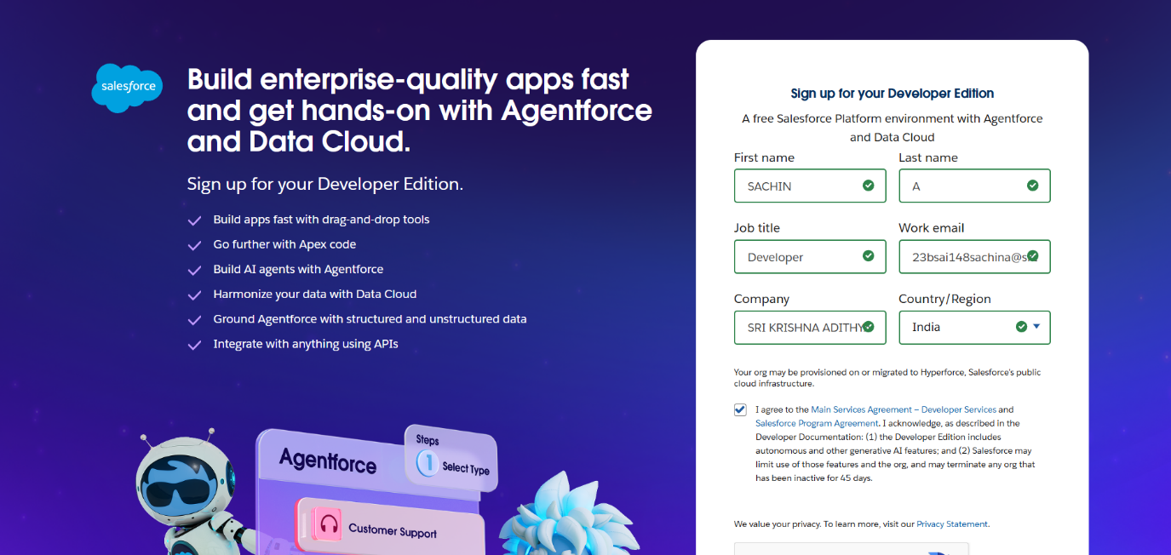

### 2.1 Objects:

* Created objects: Product, Purchase Order, Order Item, Inventory Transaction and Supplier

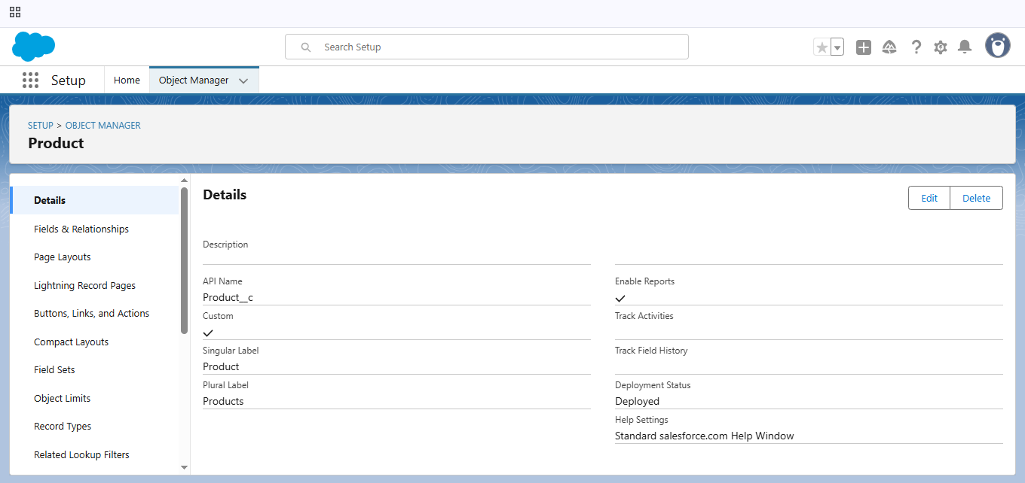

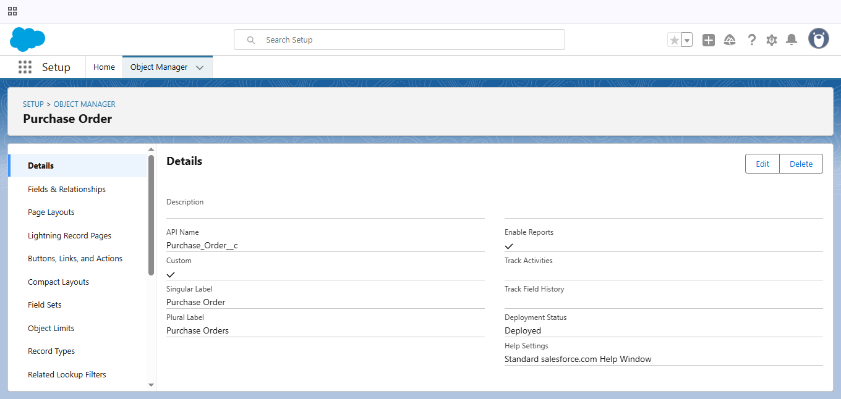

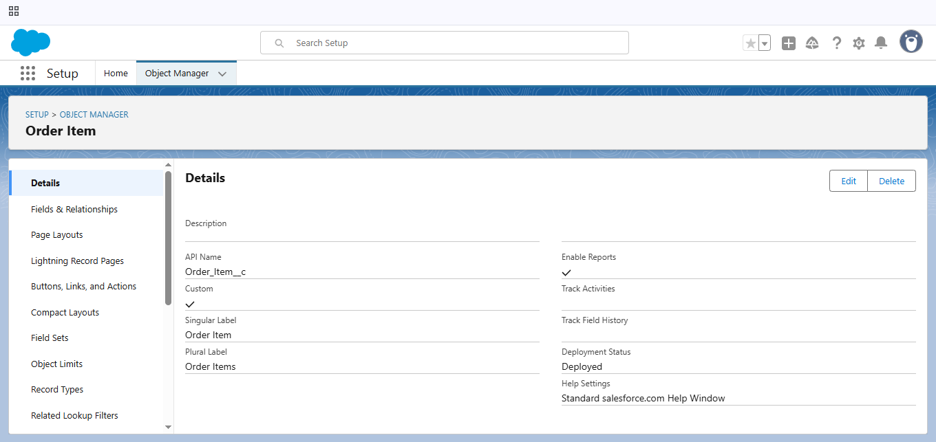

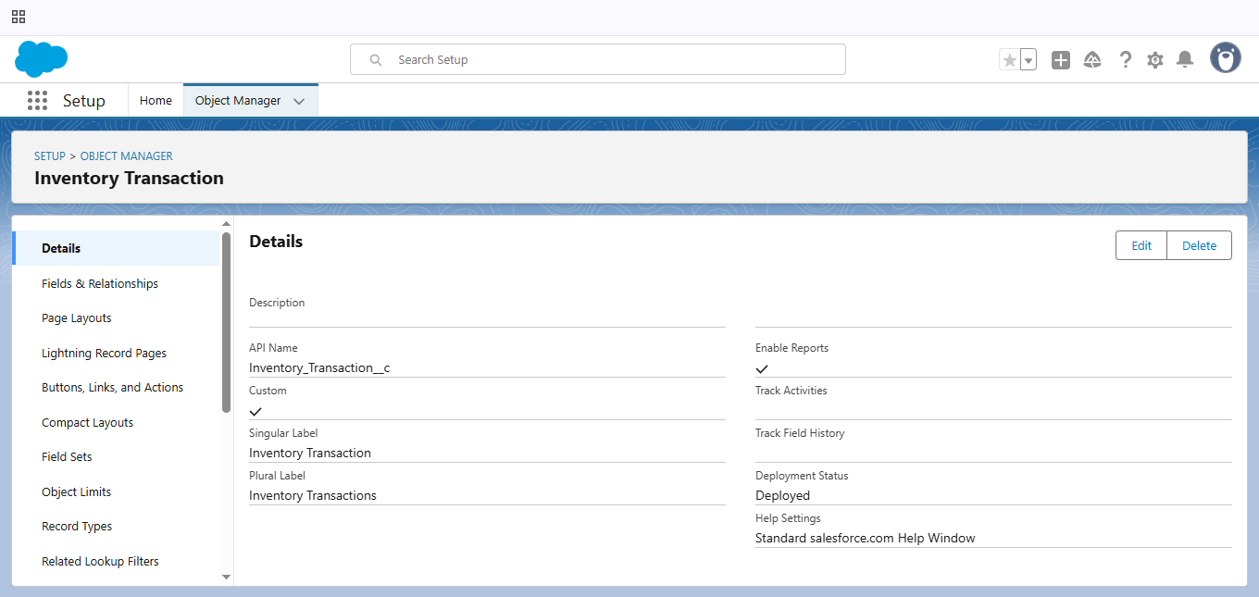

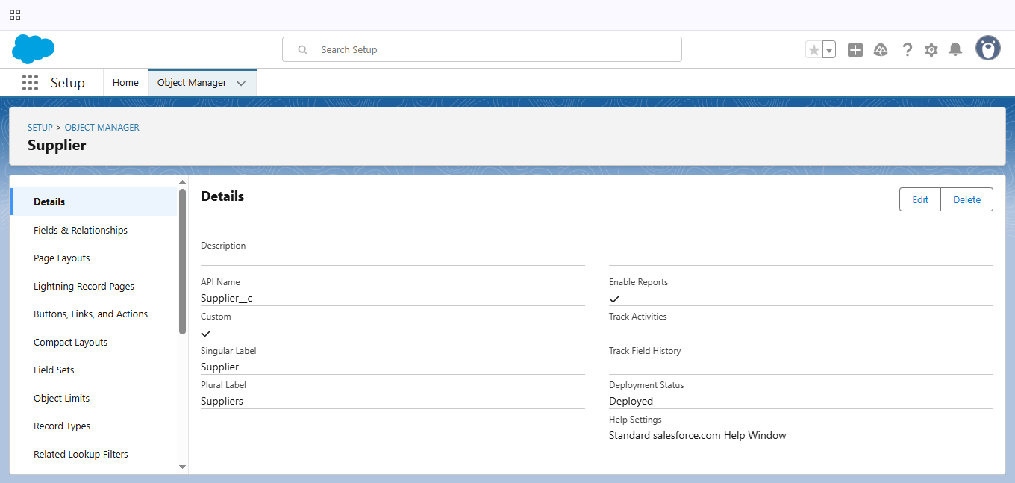

### 2.2 Tabs:

* Creating Tabs for created objects:

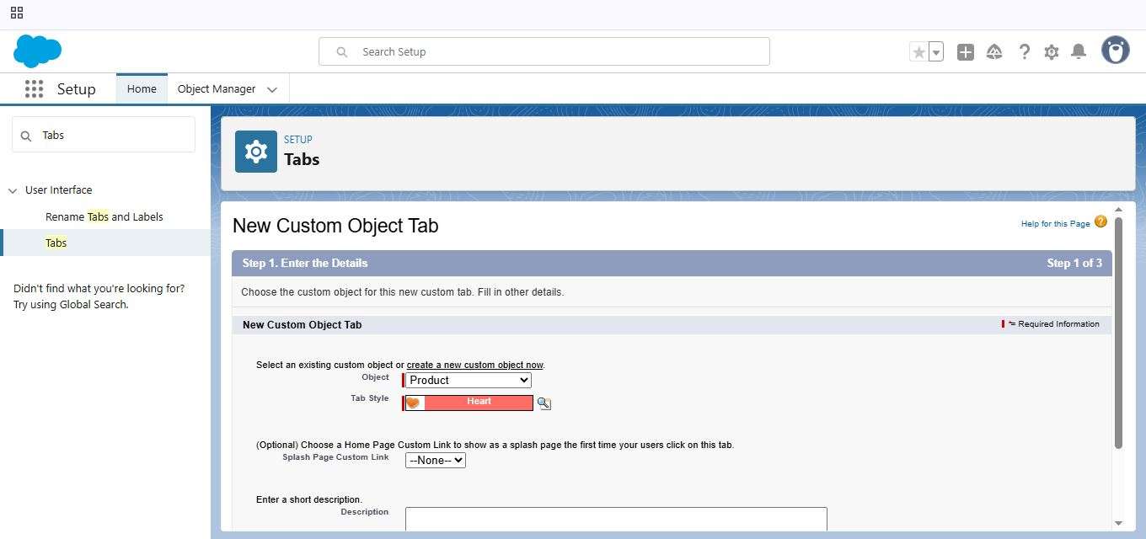

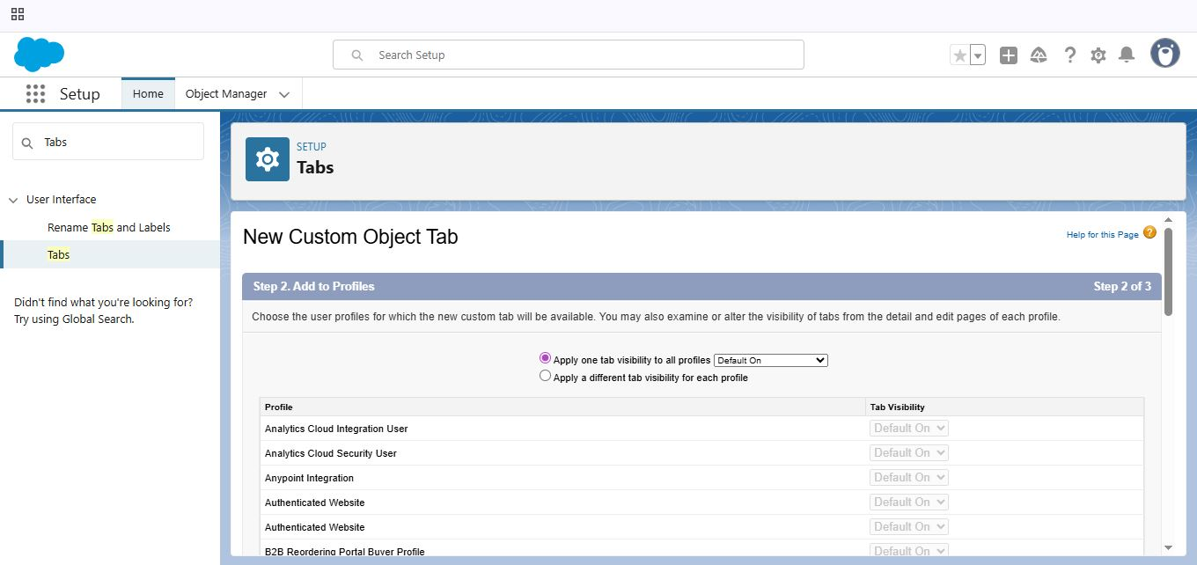

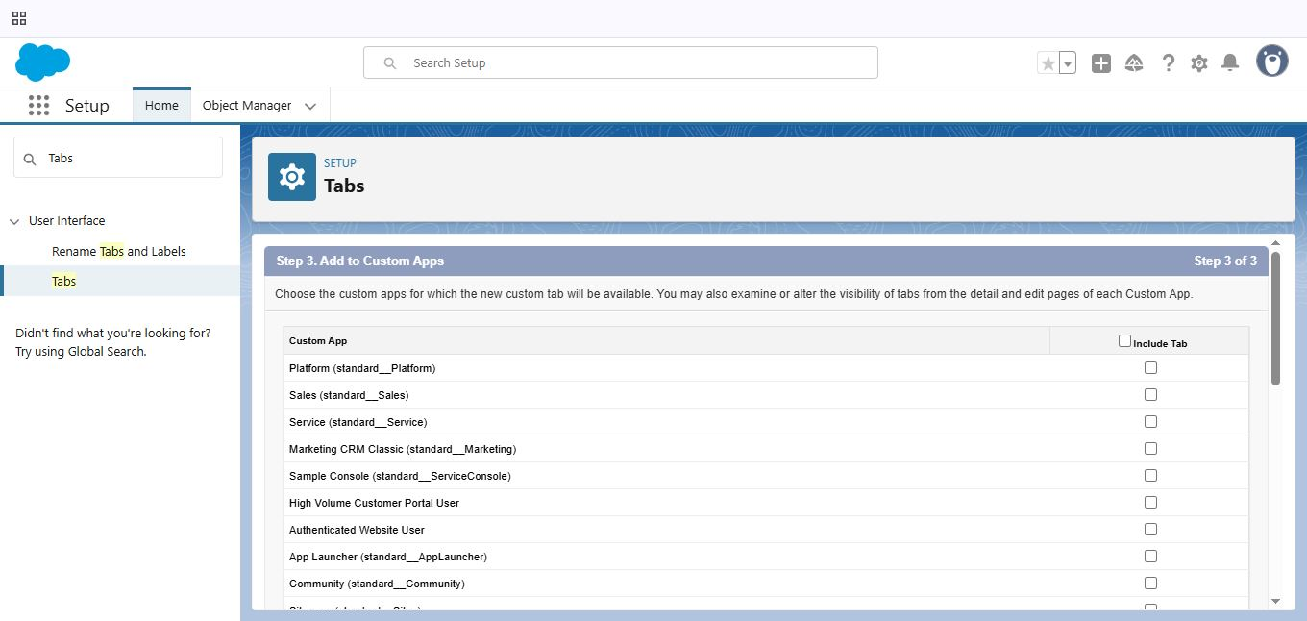

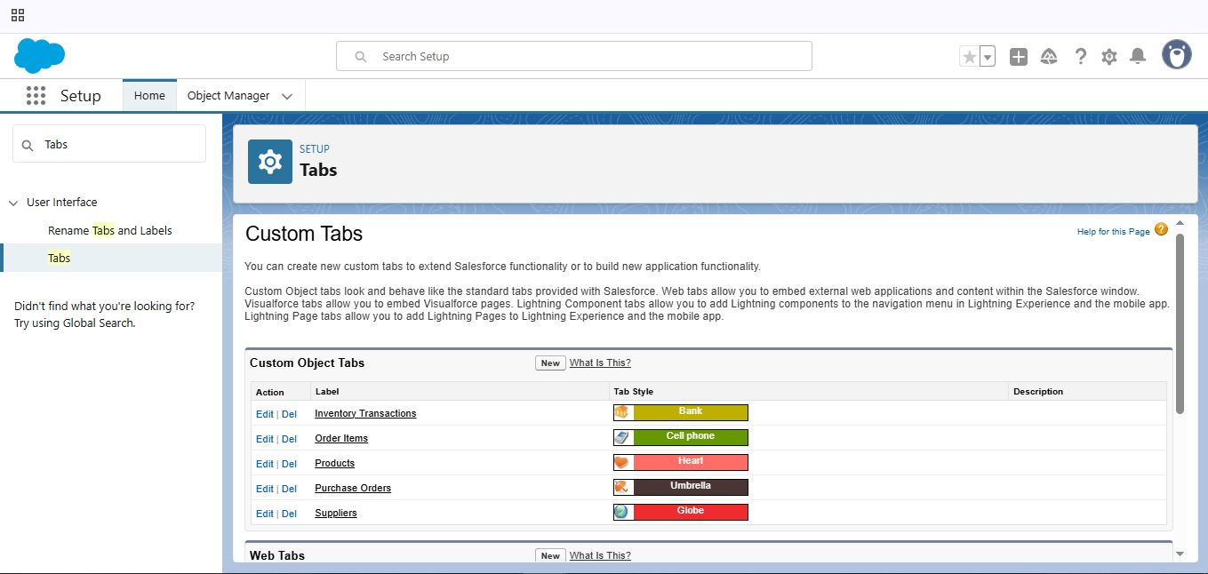

Creating the Tabs for the remaining Objects same like this process, they are “Purchase Order, Order Item, Inventory Transaction, and Supplier”.

### 2.3 The Lightning App:

* Create a Lightning App for Medical Inventory Management:

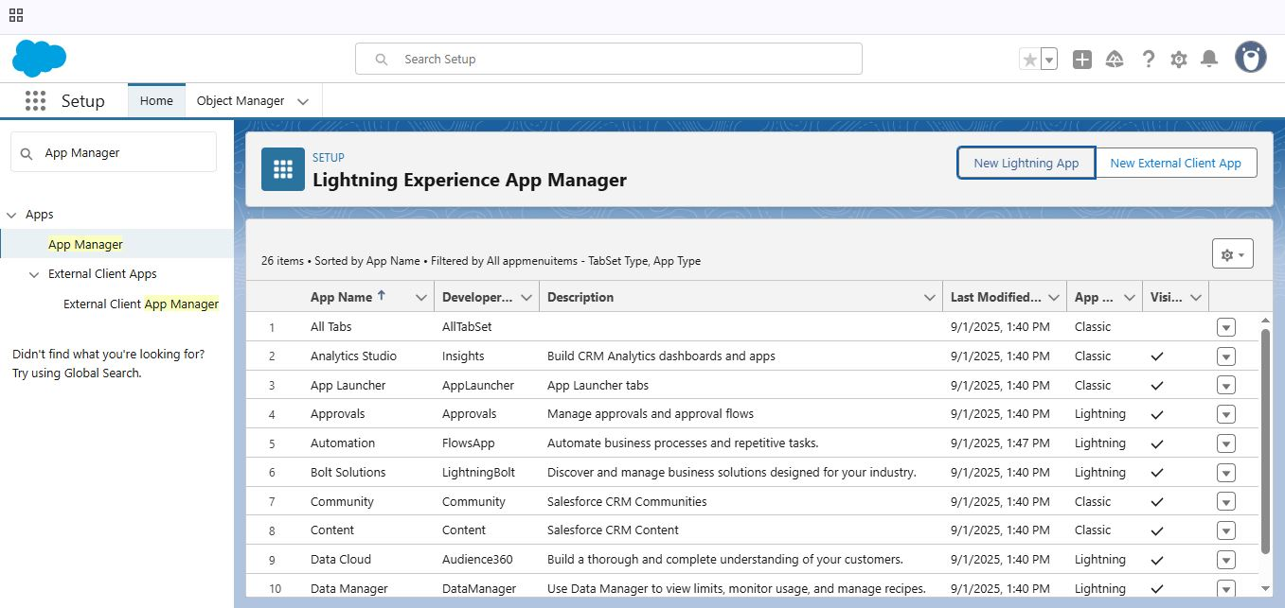

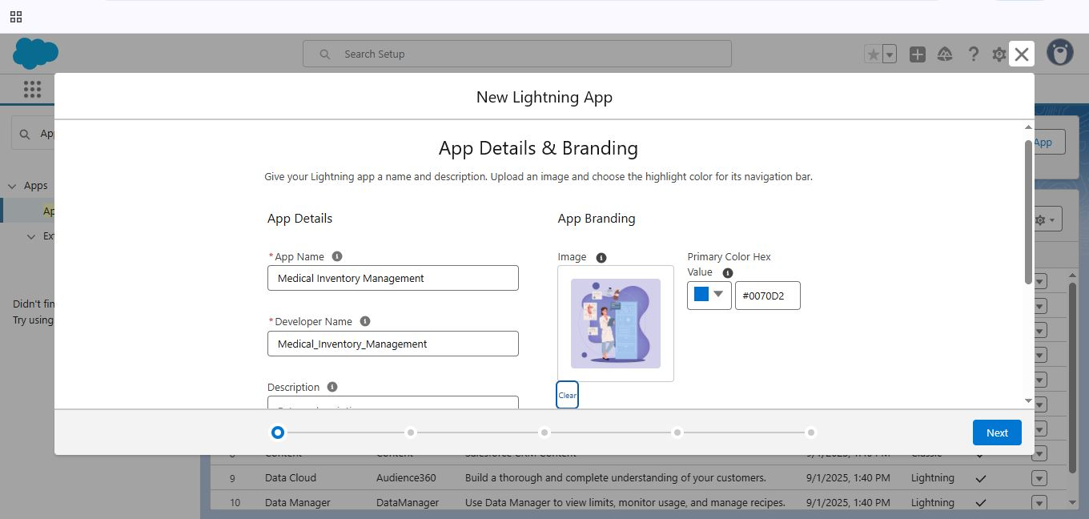

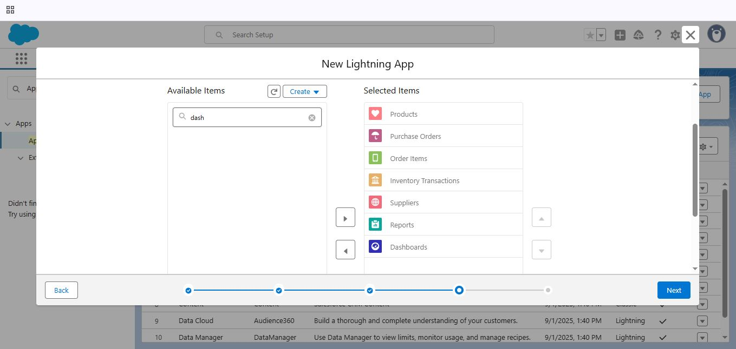

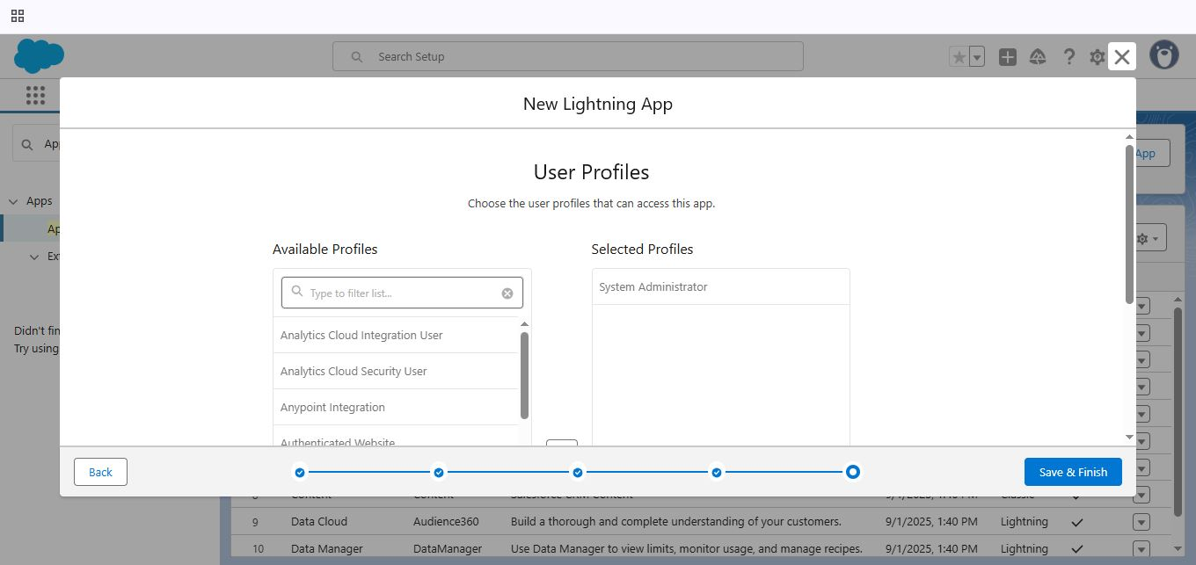

### 2.4 Fields:

* Creating a Text (“Product Name”), Text Area (“Product Description”), Number (“Current Stock Level”), Currency (“Unit Price”) Fields in Product Object:

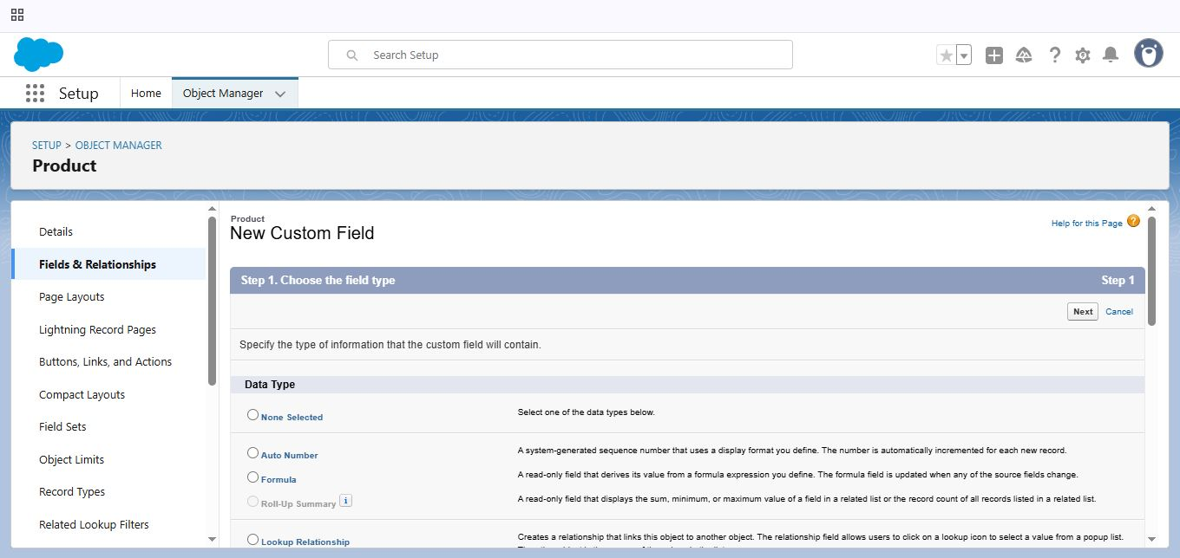

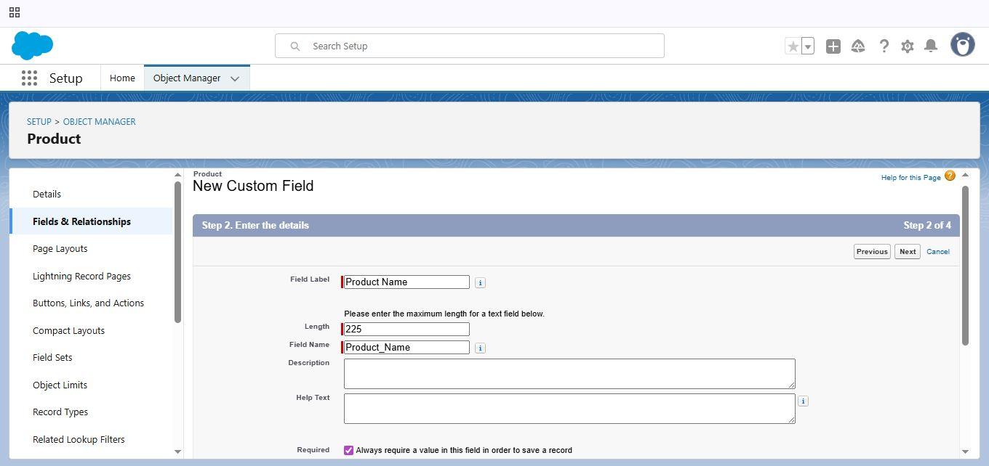

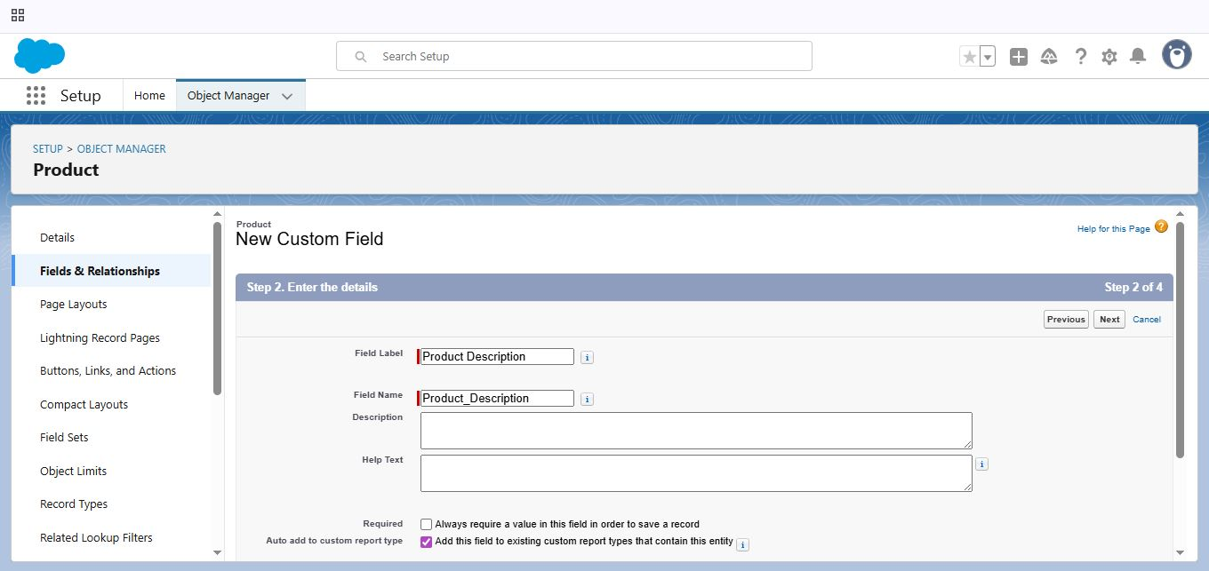

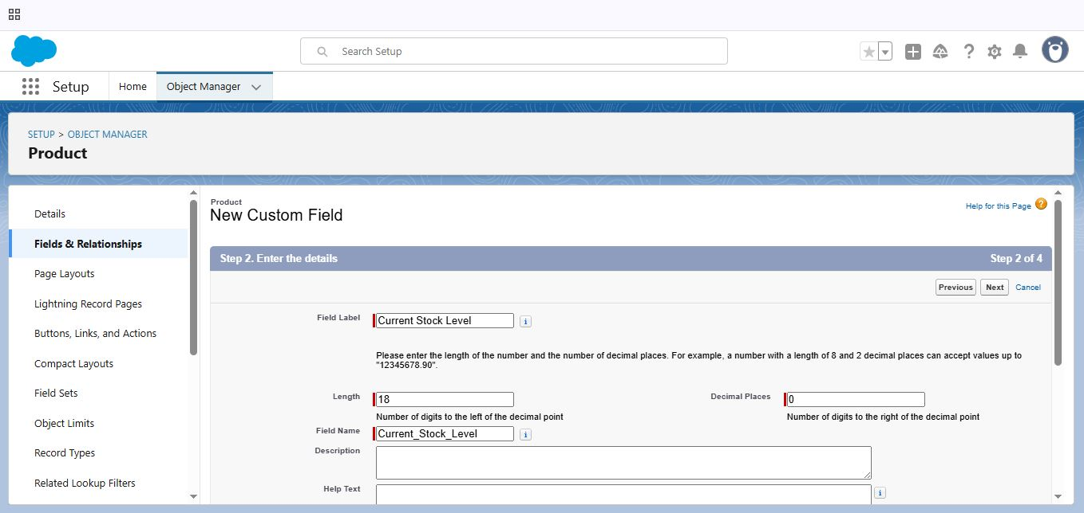

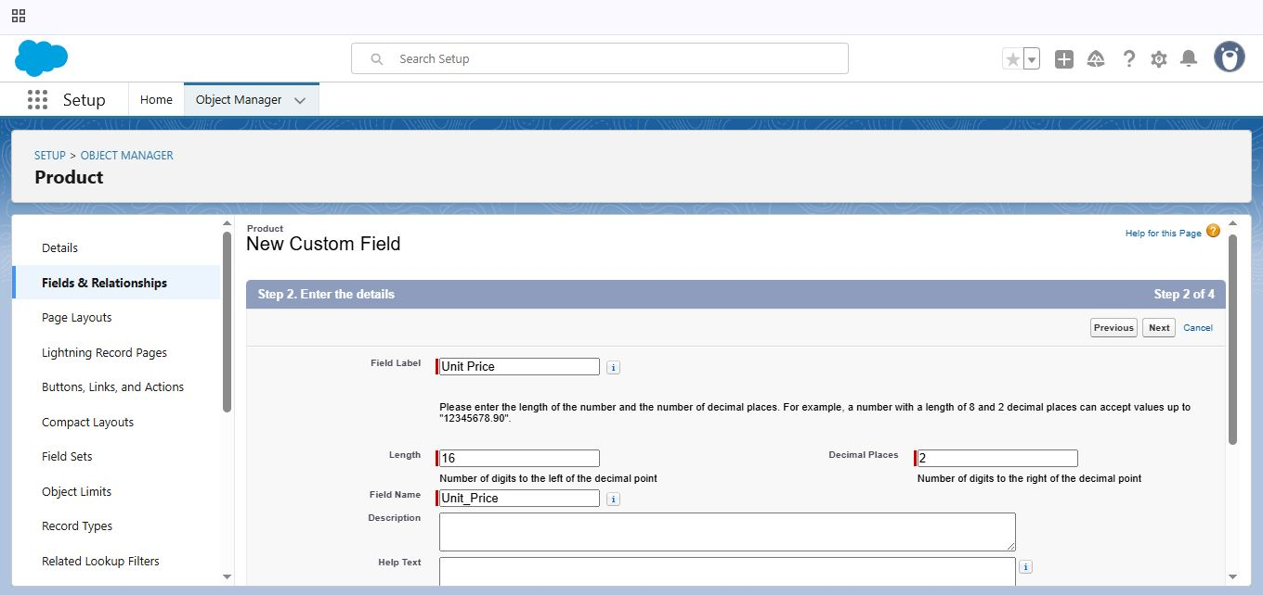

* Creating a Lookup Relationship ( “Supplier ID” ), Date Field (“ Order Date”), Roll-up Summary Field (“Order Count”) in Purchase Order Object:

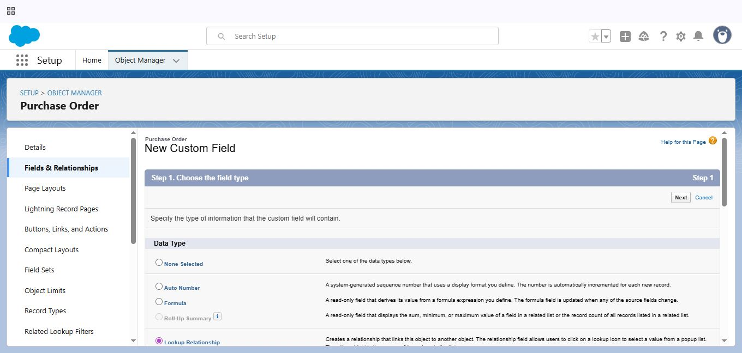

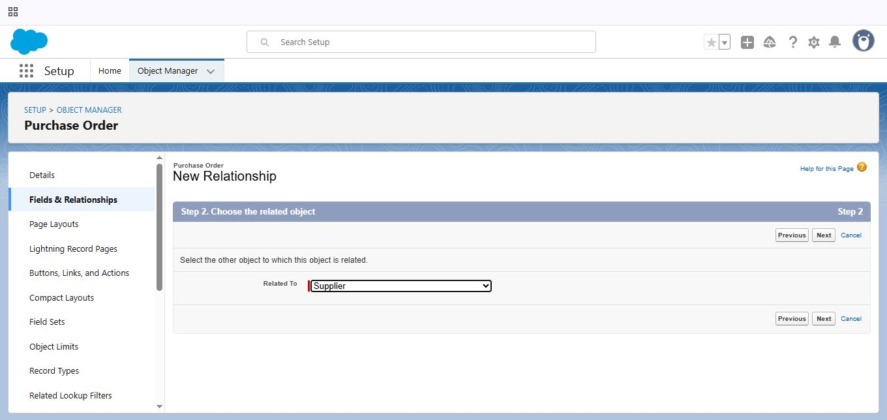

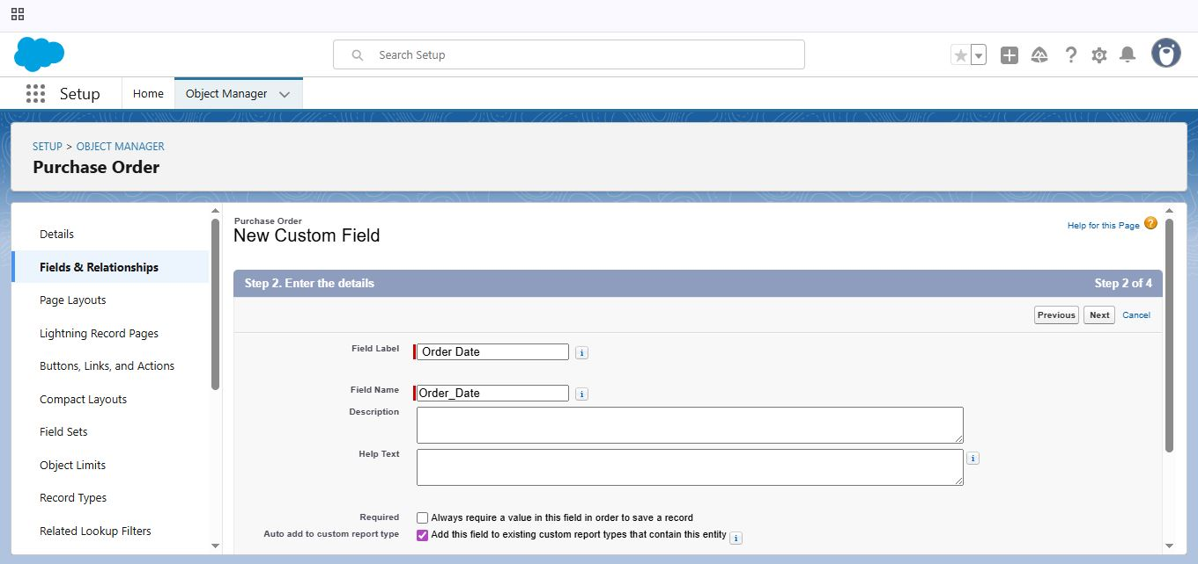

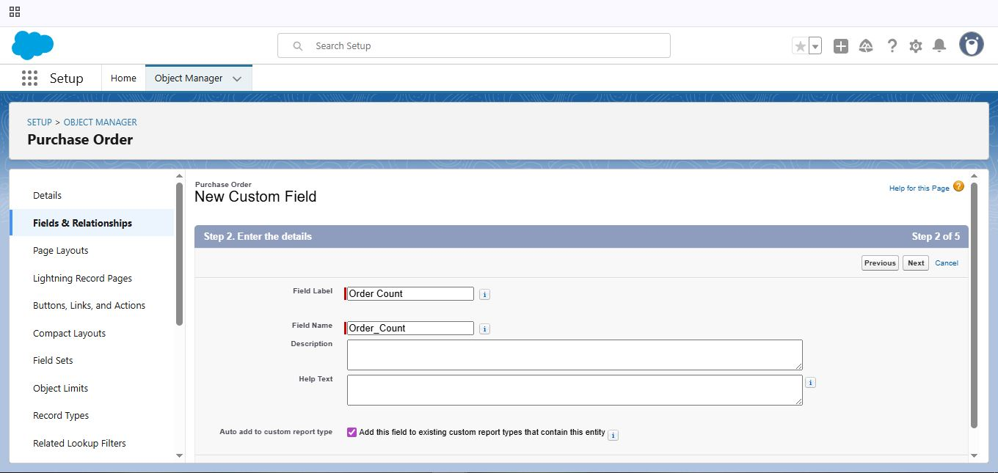

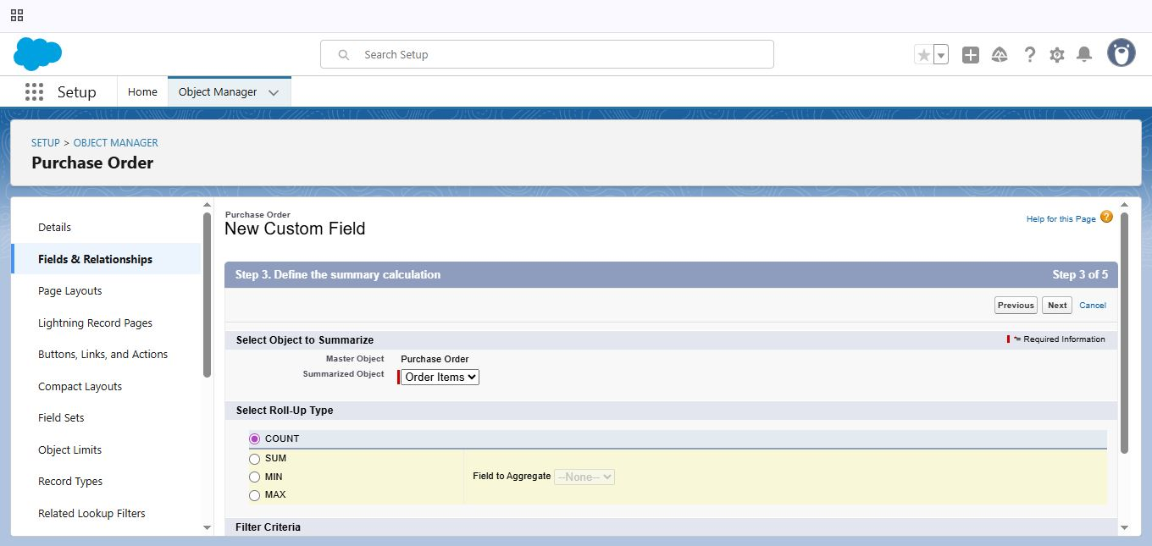

* Creating a Unit Price Formula (“Unit Price”), Amount Formula (“Amount”)Fields in Order Item Object:

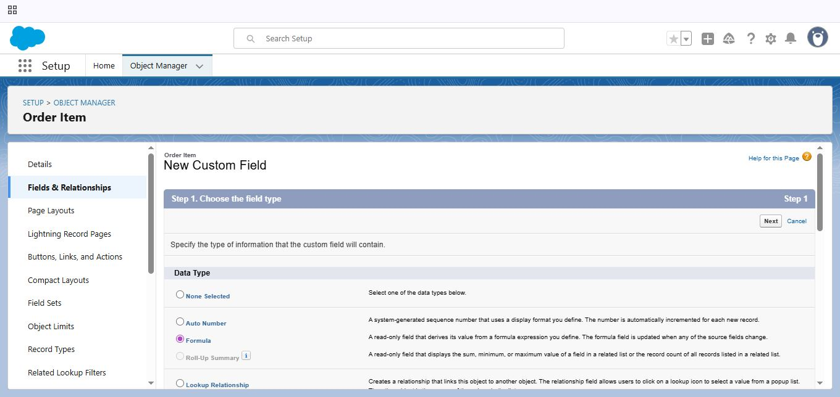

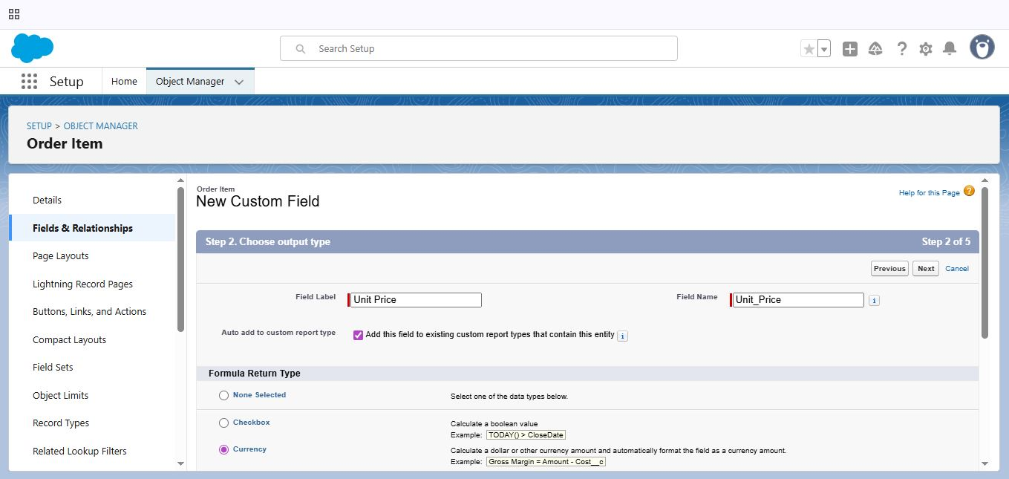

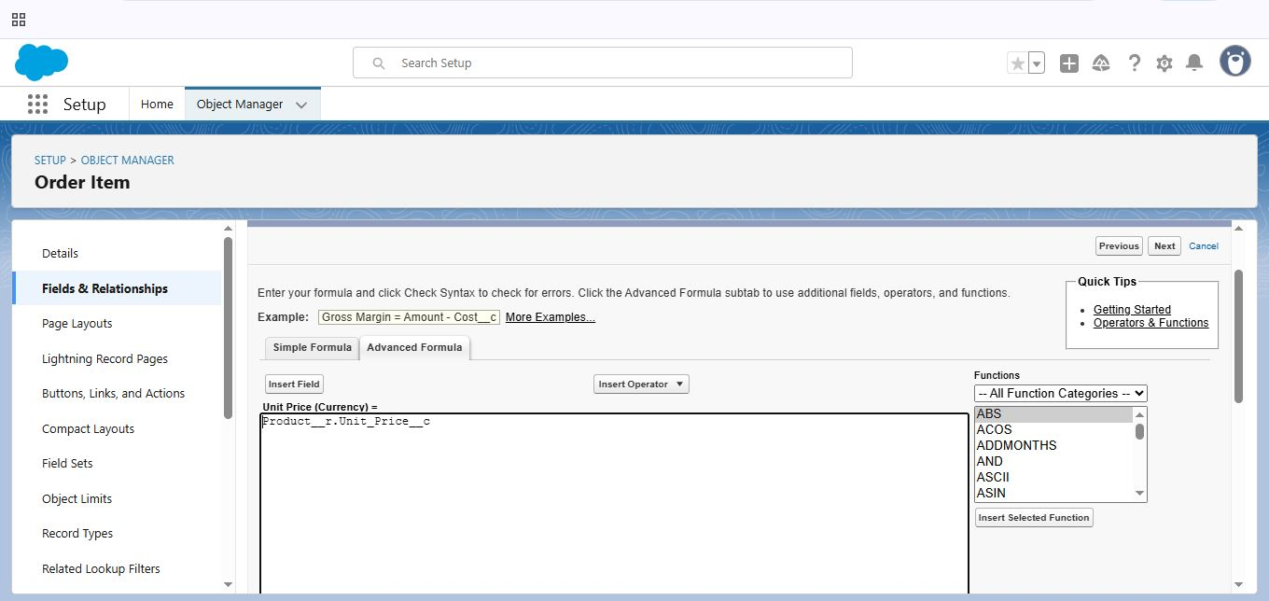

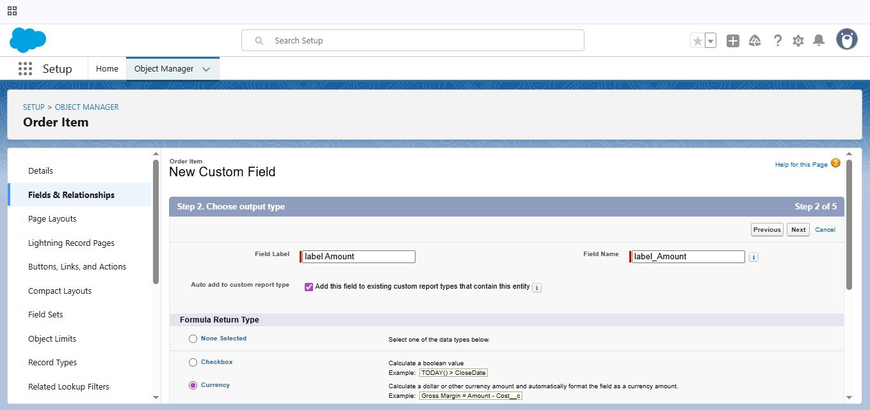

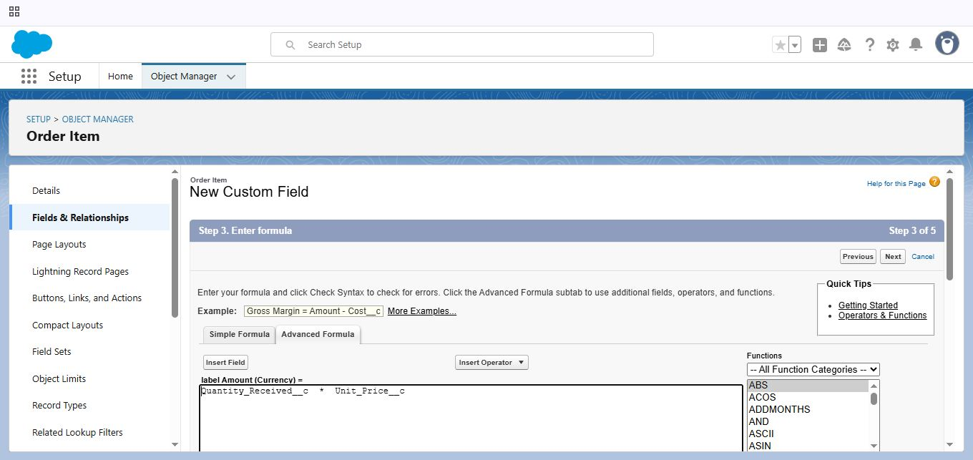

* Creating a Picklist Field (“Transaction Type”), Total Order Cost Formula Field (“Total Order Cost”) in Inventory Transaction Object:

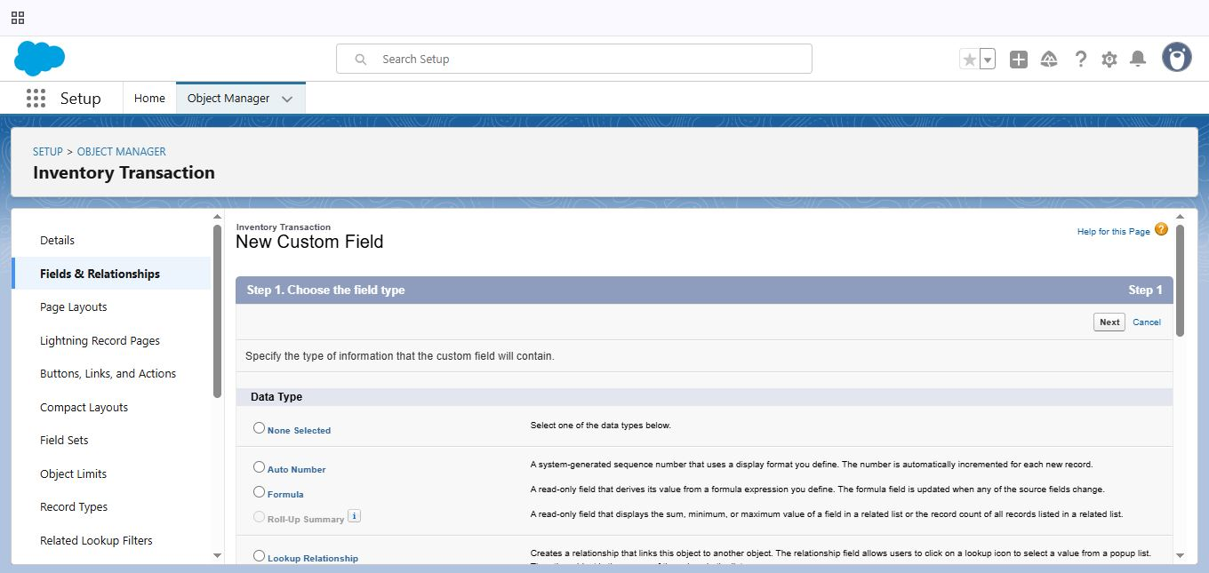

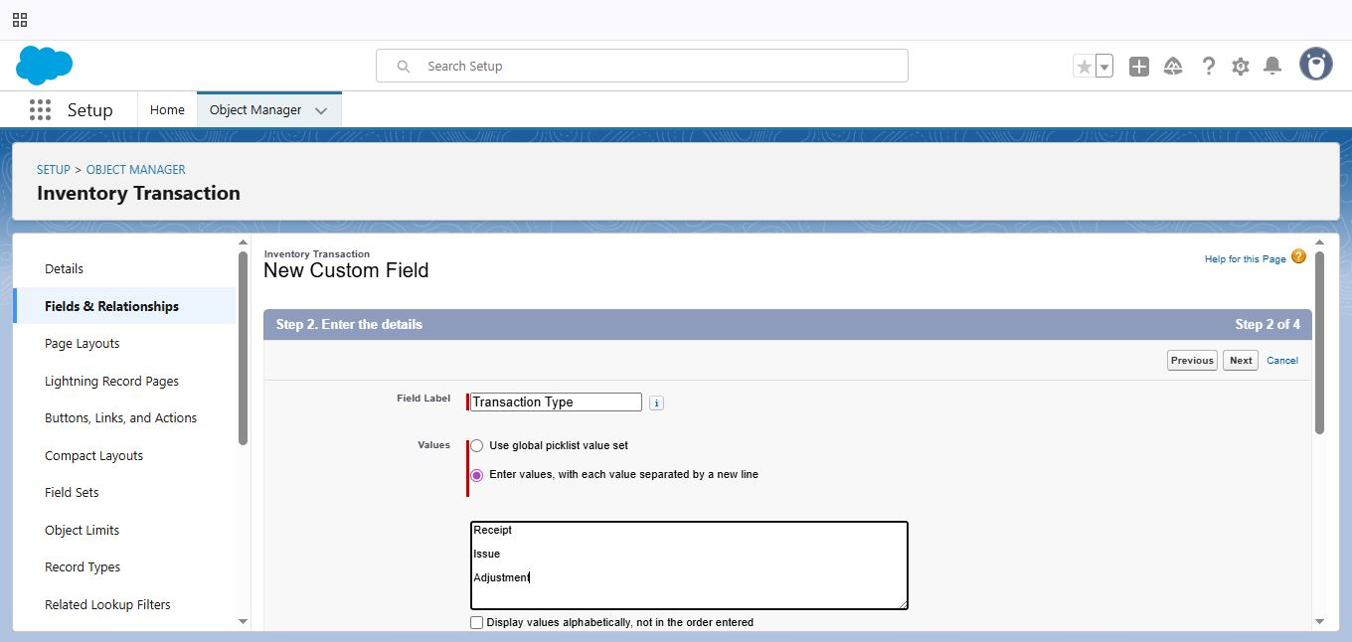

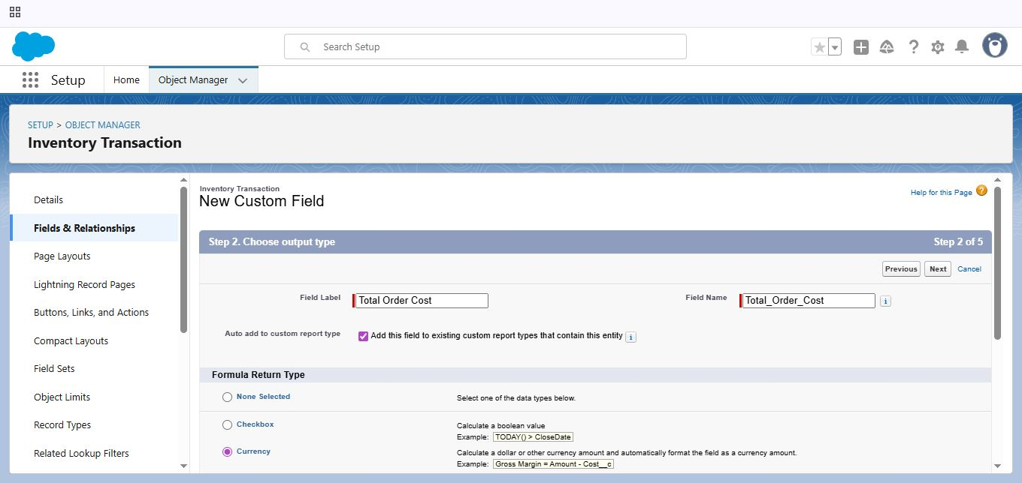

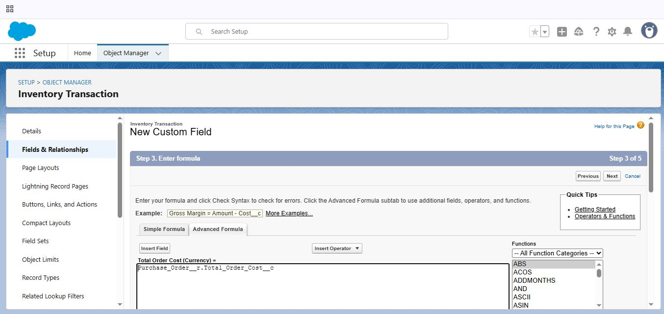

* Creating a Phone (“ Phone Number”), Email (“Email”) Fields in Supplier Object:

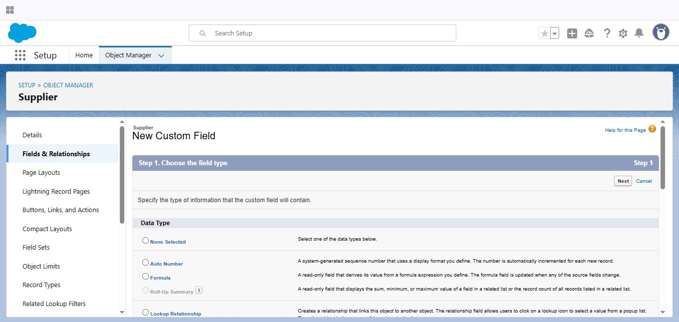

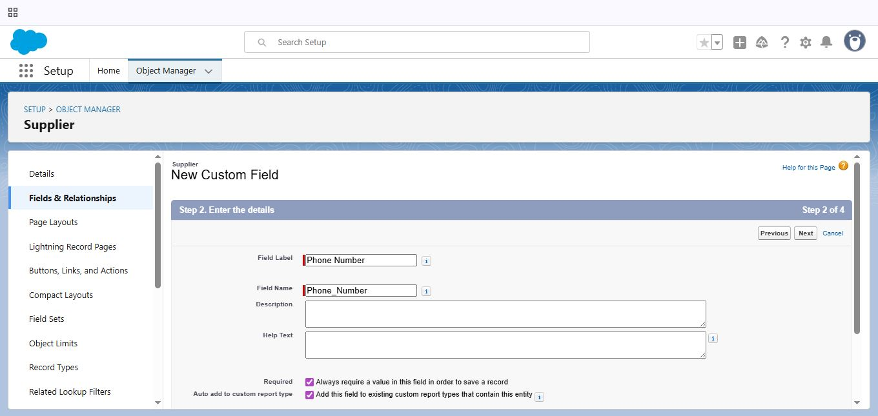

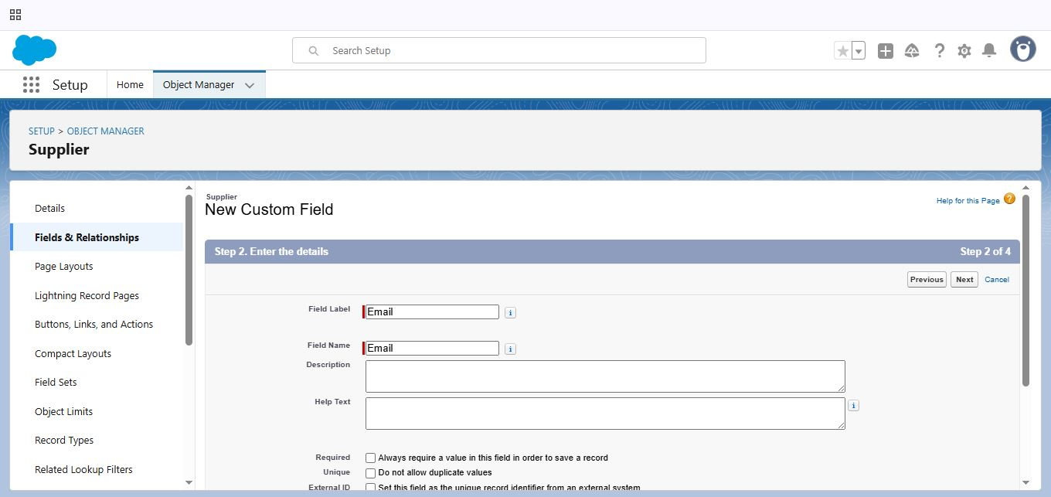

### 2.5 Editing of Page Layouts:

* To edit a page Layout in Product object:

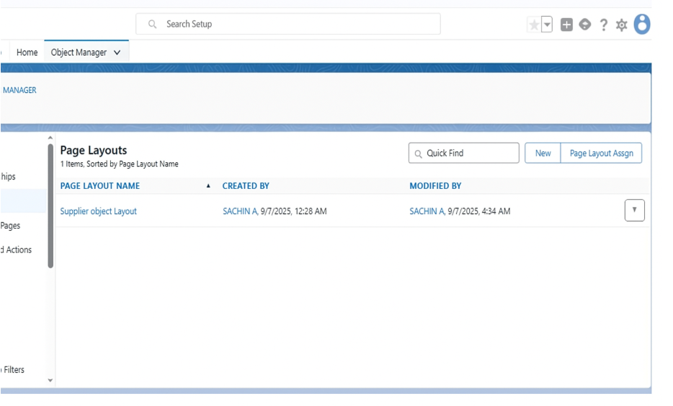

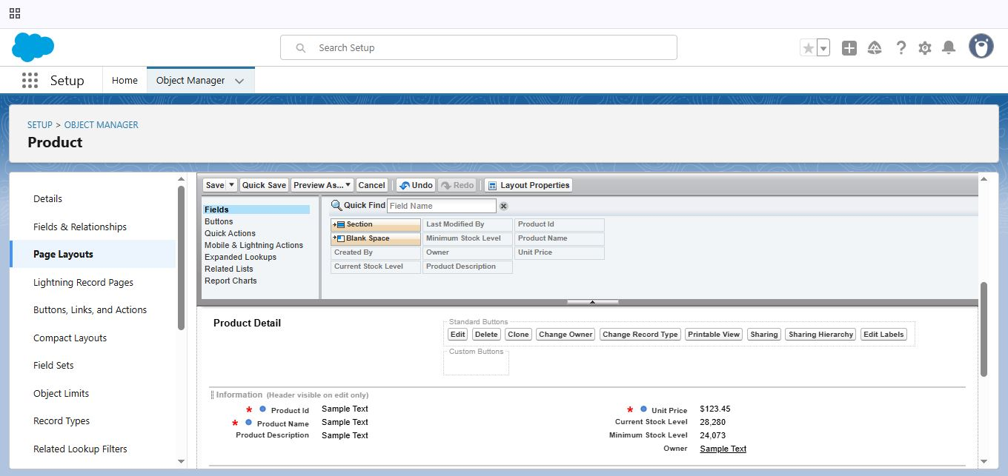

* To edit a page Layout in Purchase Order object:



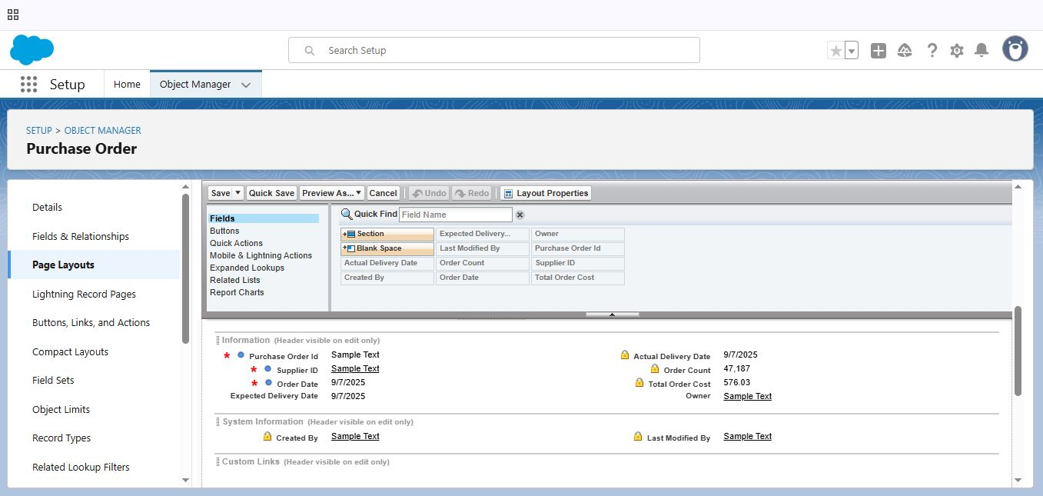

* To edit a page Layout in Order Item object:



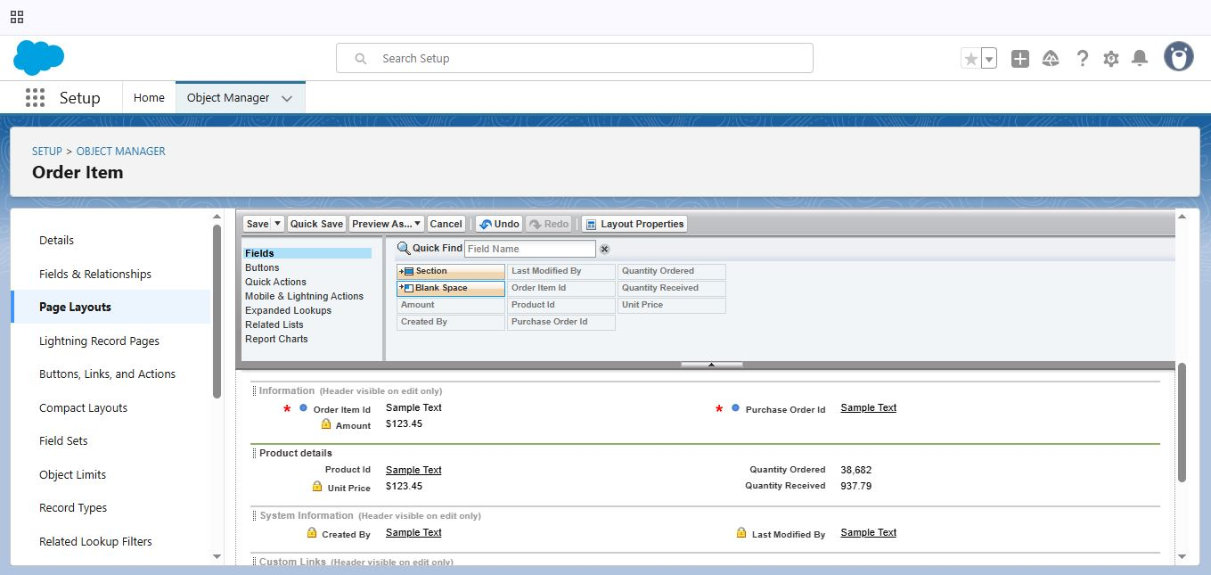

* To edit a page Layout in Inventory Transaction object:



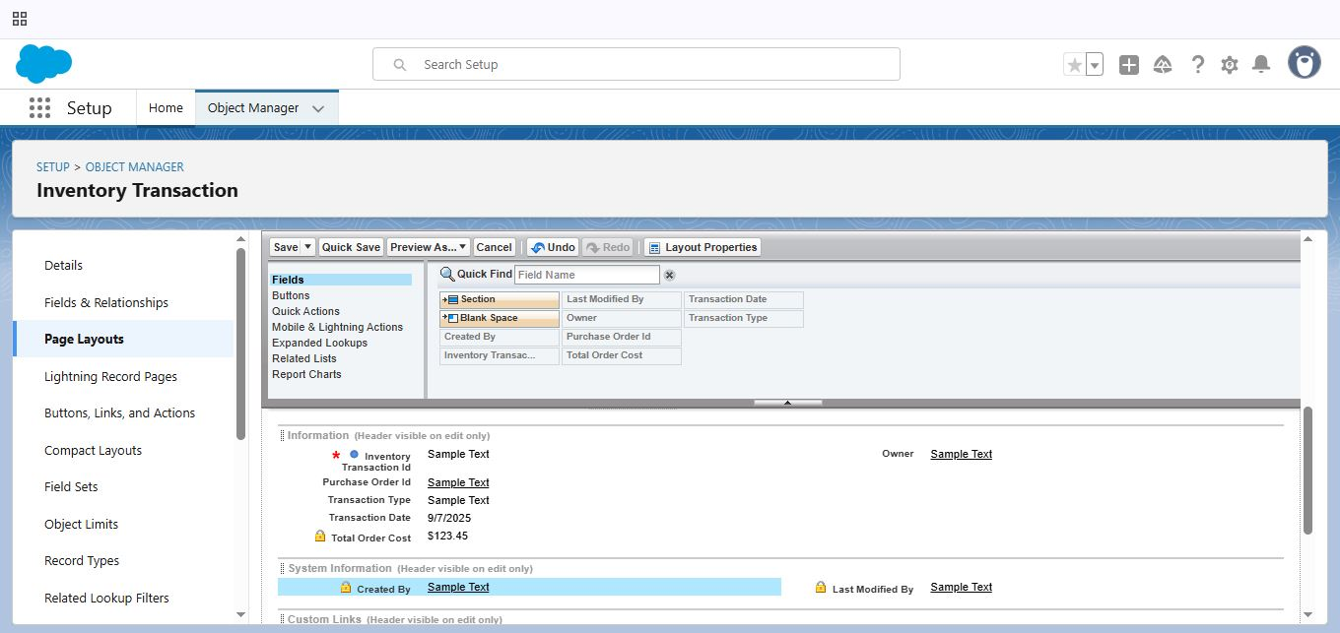

* To edit a page Layout in Supplier object:



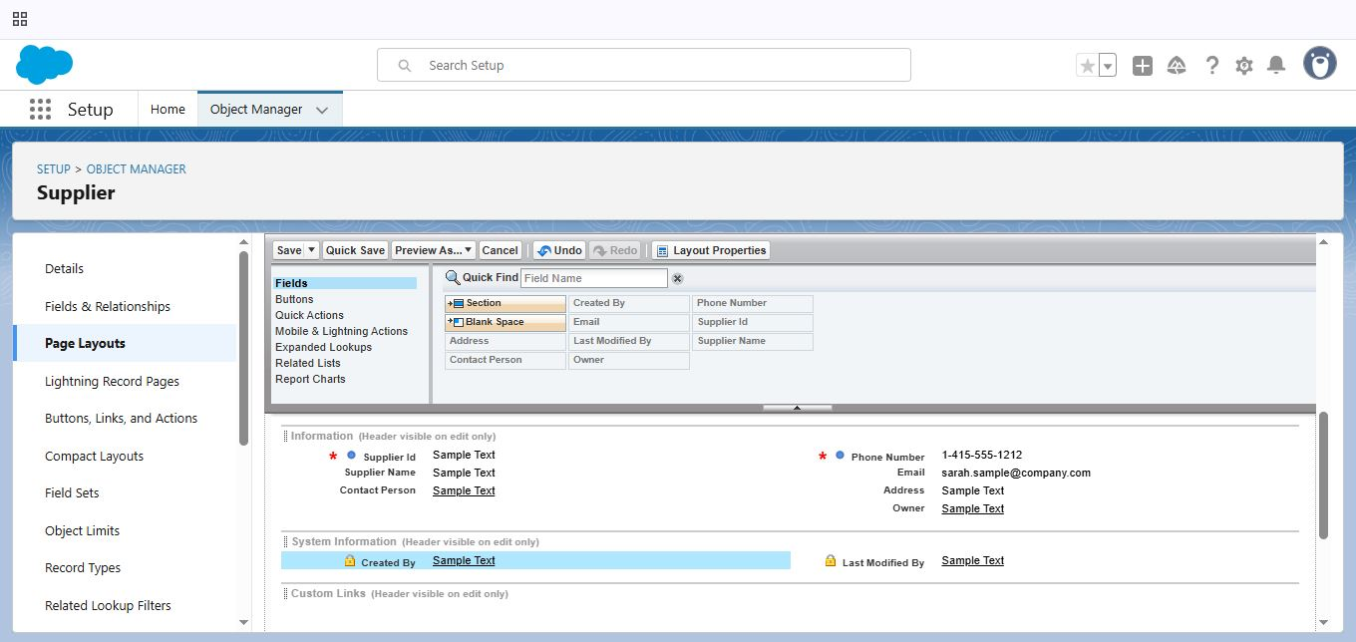

### 2.6 Compact Layouts:

* To Create a Compact Layout to a Product Object:

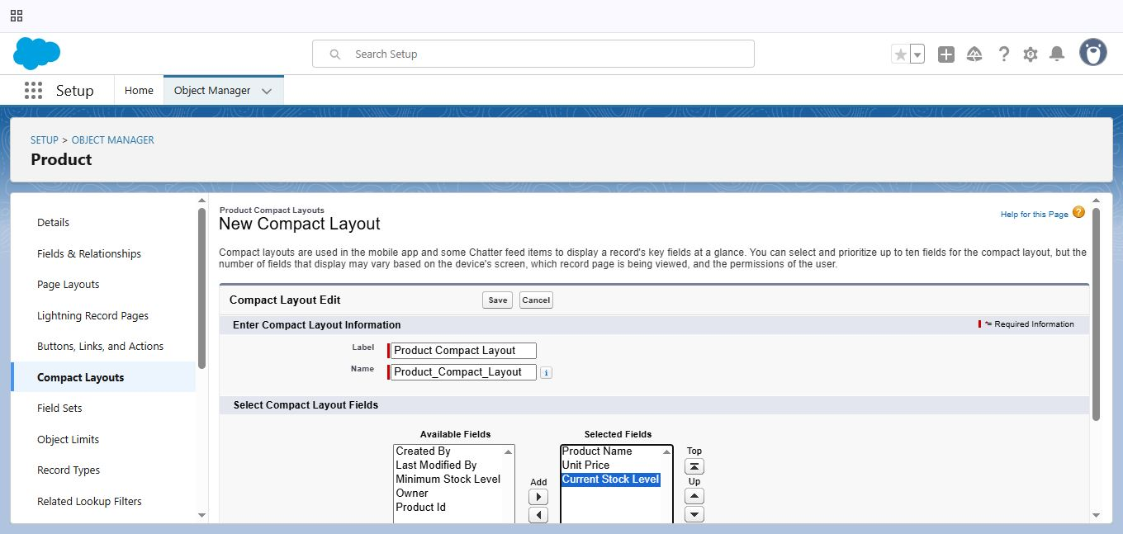

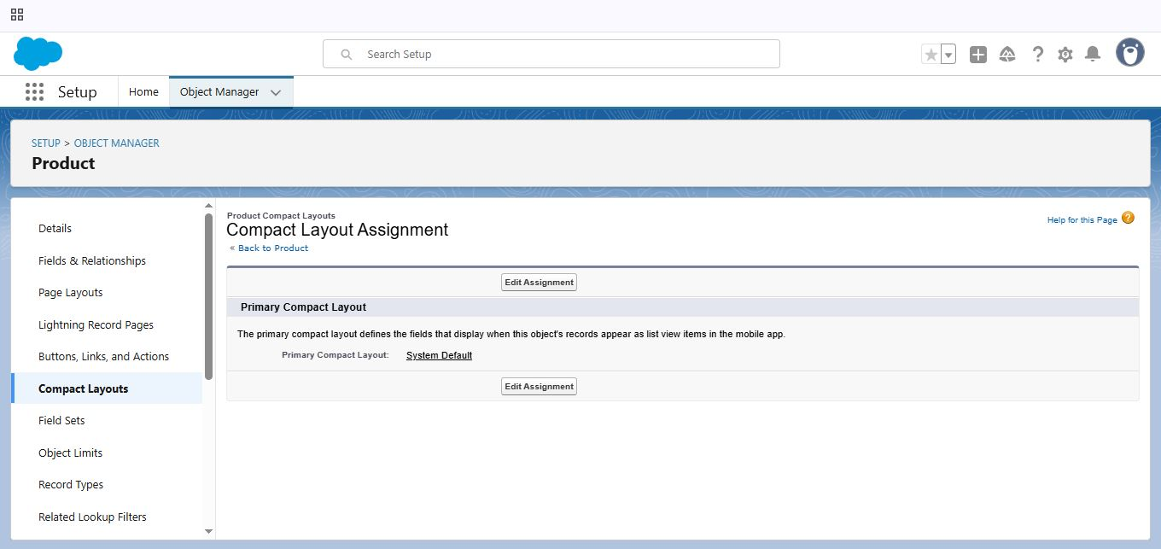

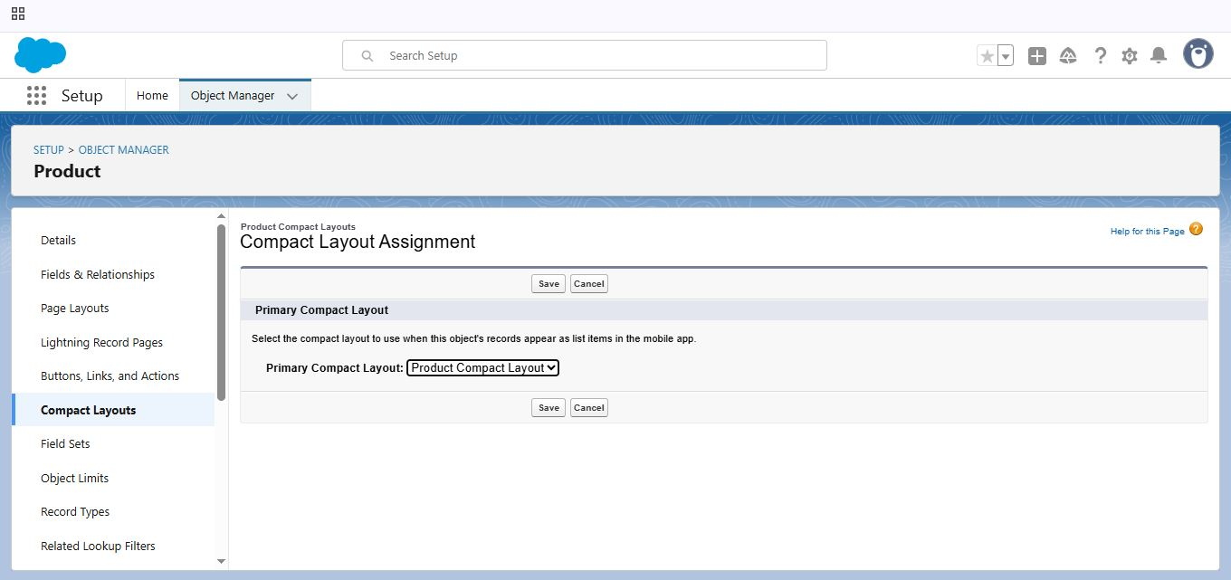

* To Create a Compact Layout to a Purchase Order Object:

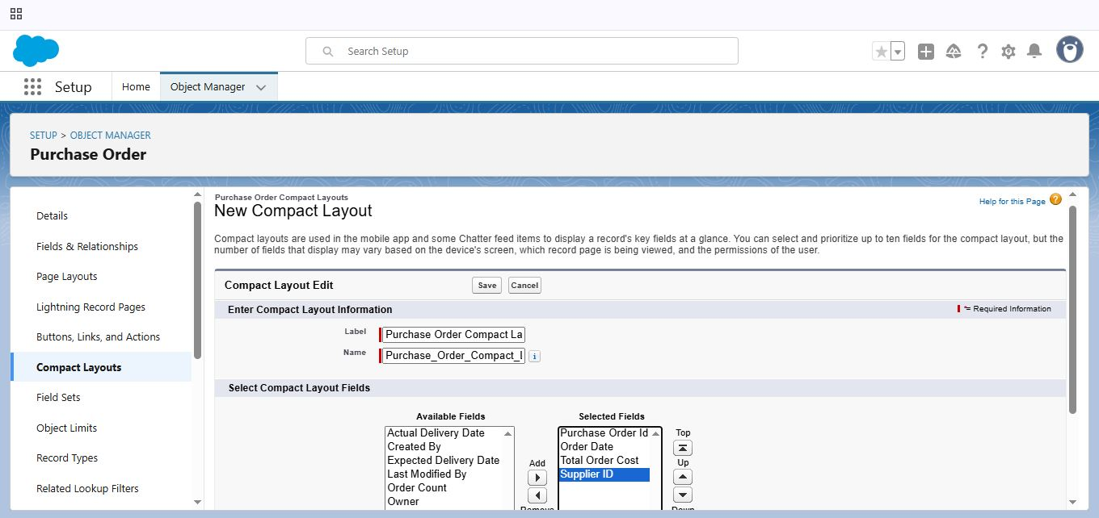

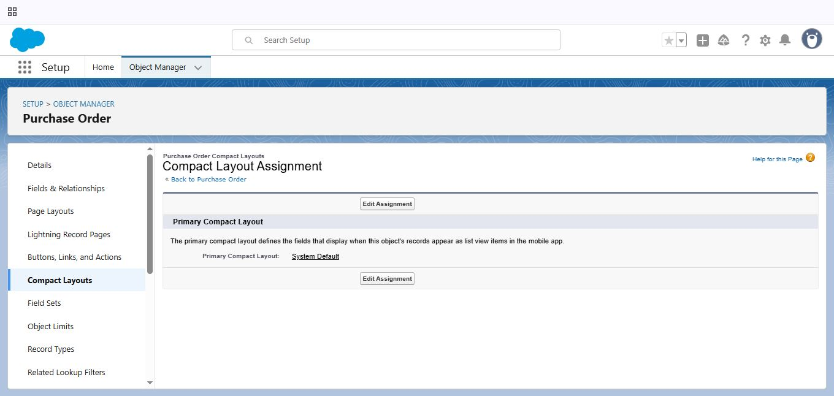

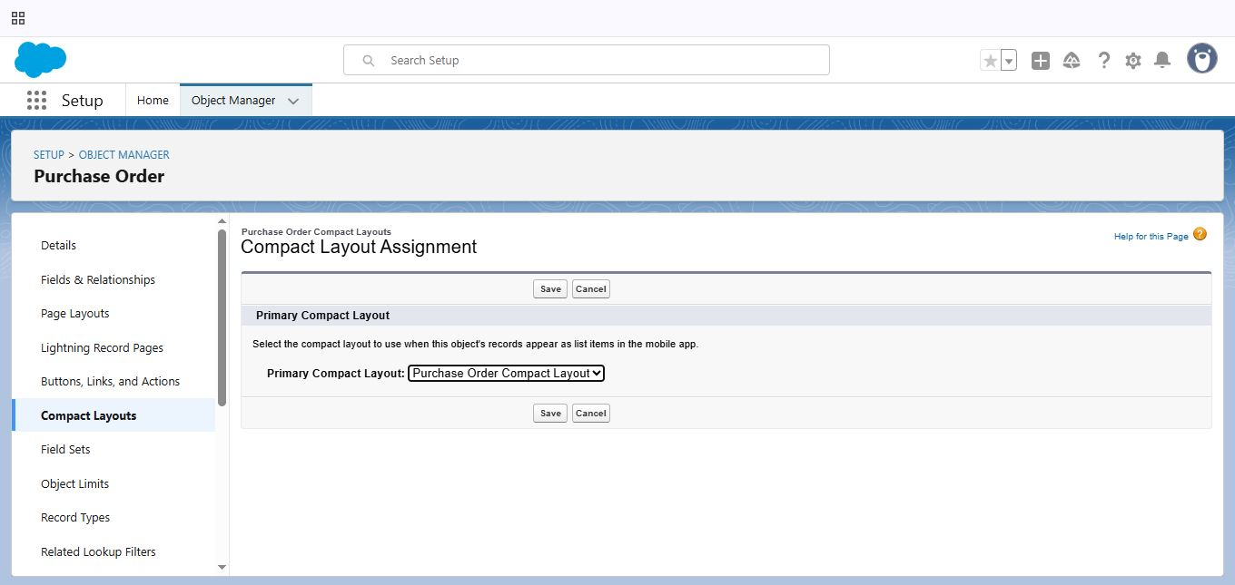

### 2.7 Validation Rules:

* To Create an Expected Delivery Date Validation Rule to a Employee Object:

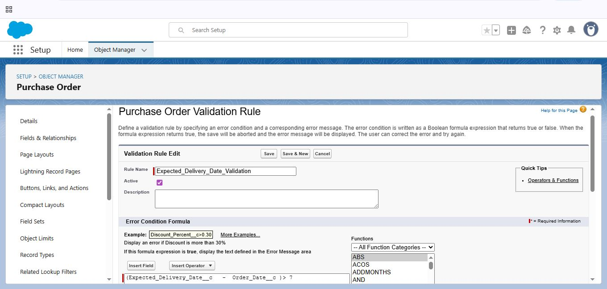

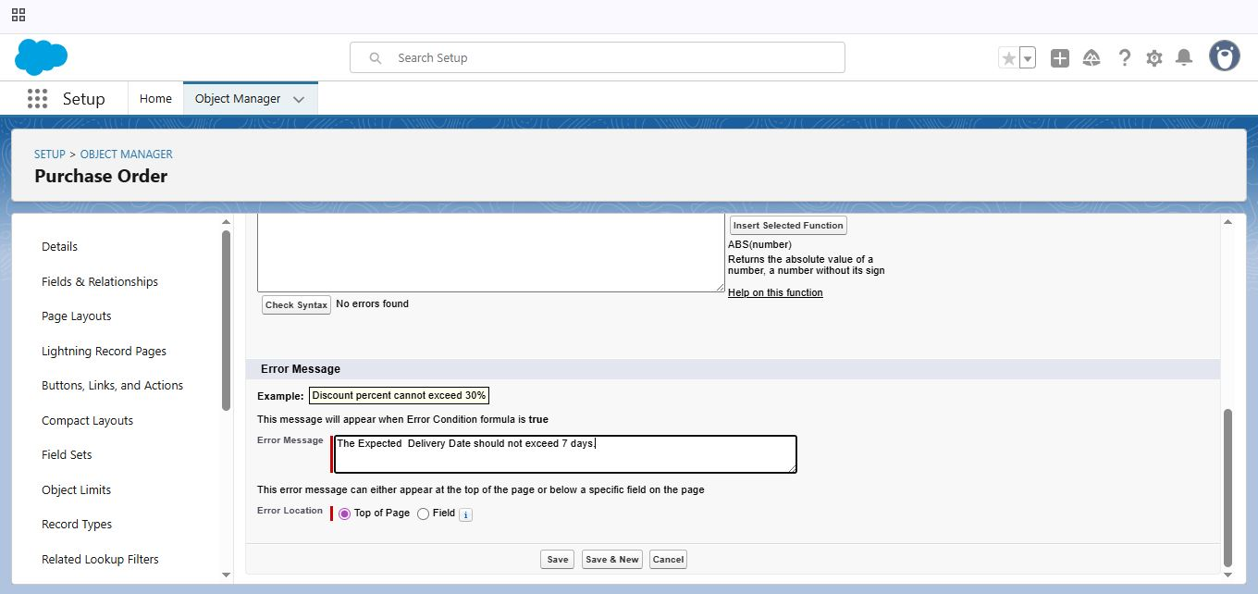

### 2.8 Profiles:

* To Create an Inventory Manager Profile:

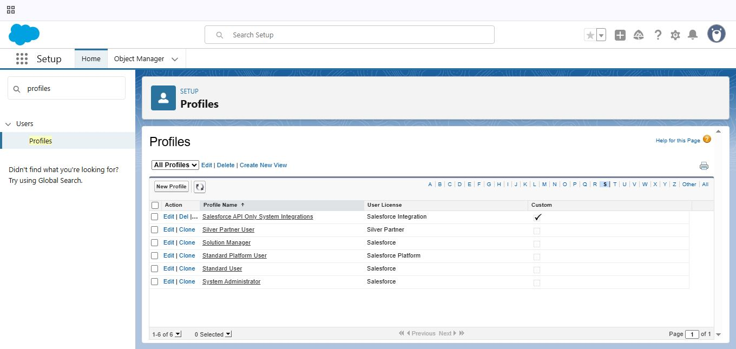

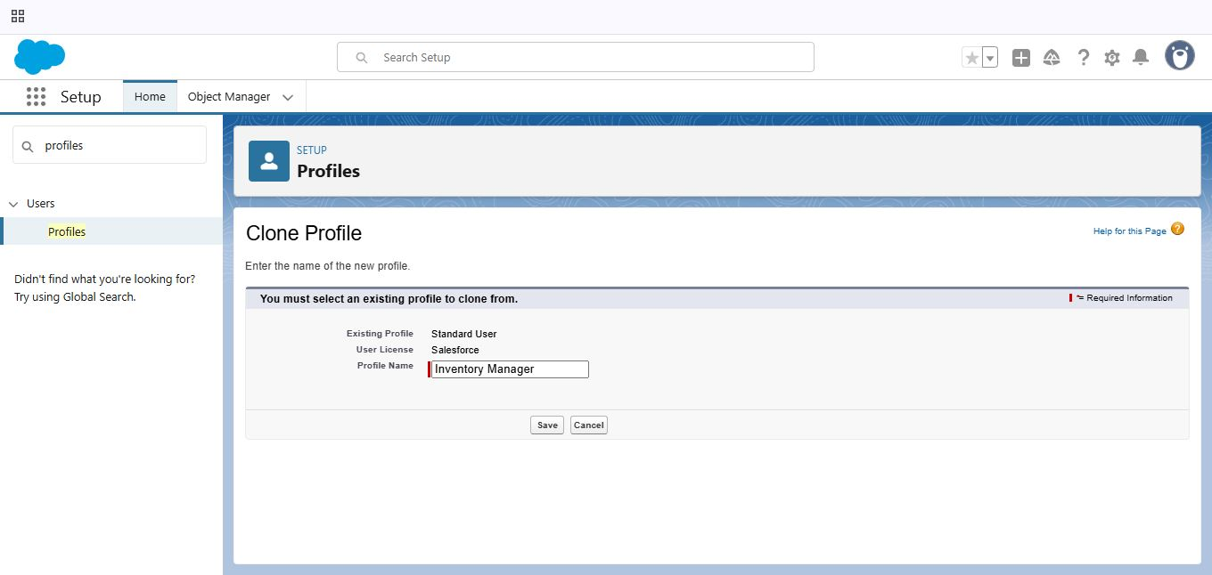

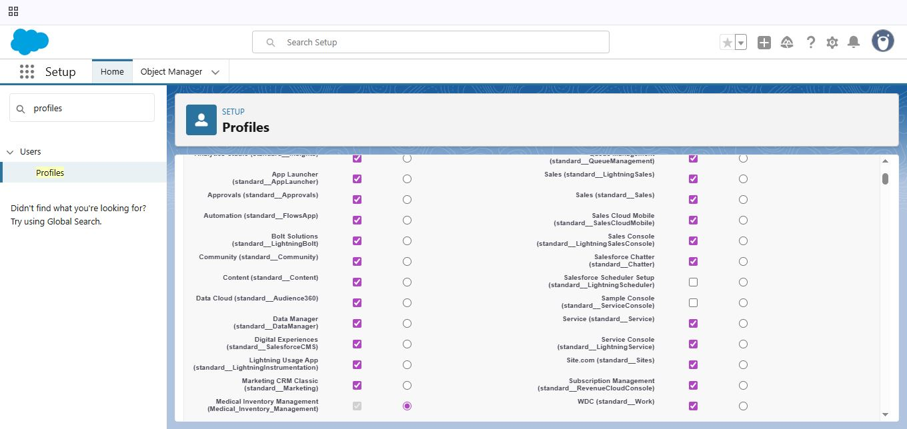

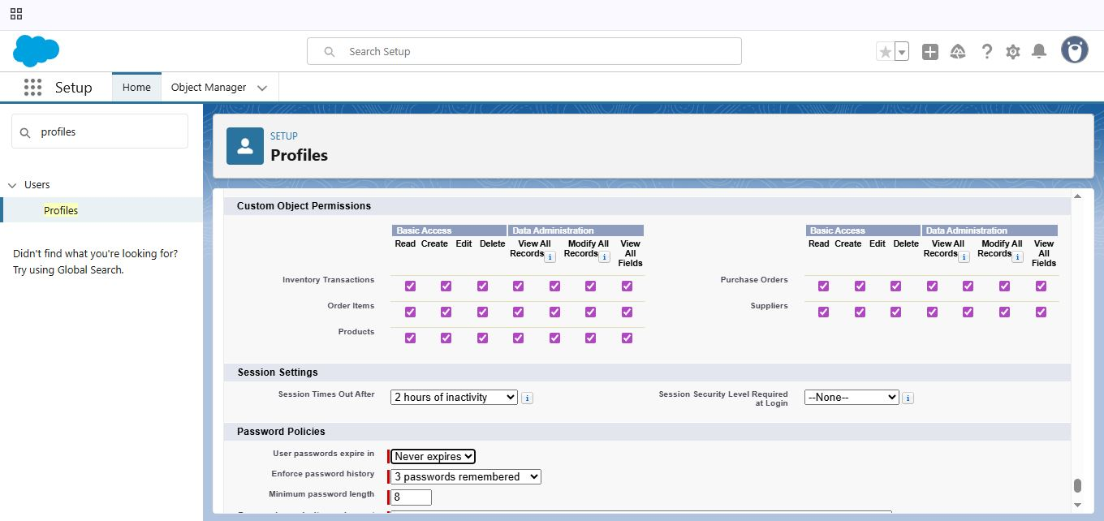

* To Create an Purchase Manager Profile:

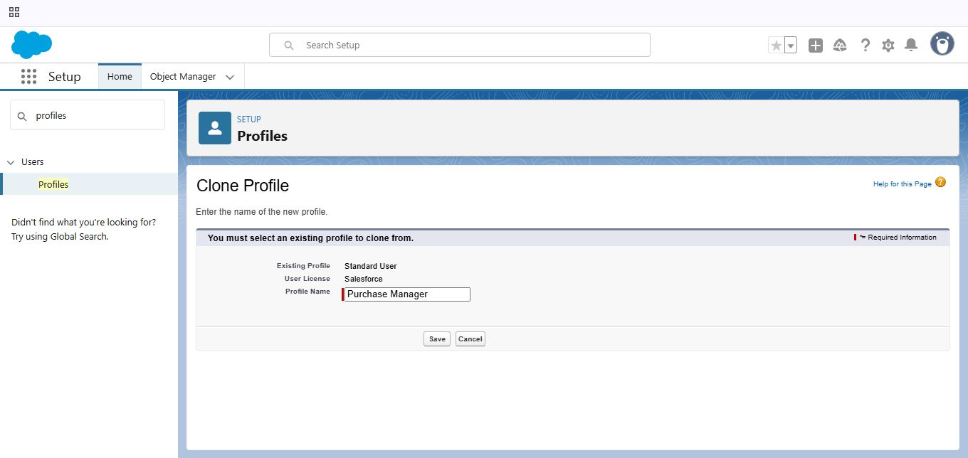

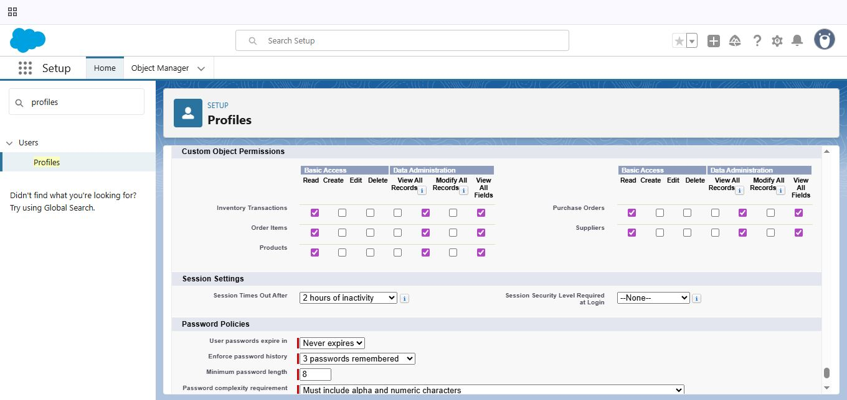

### 2.9 Roles:

* Create a Purchasing Manager Role:

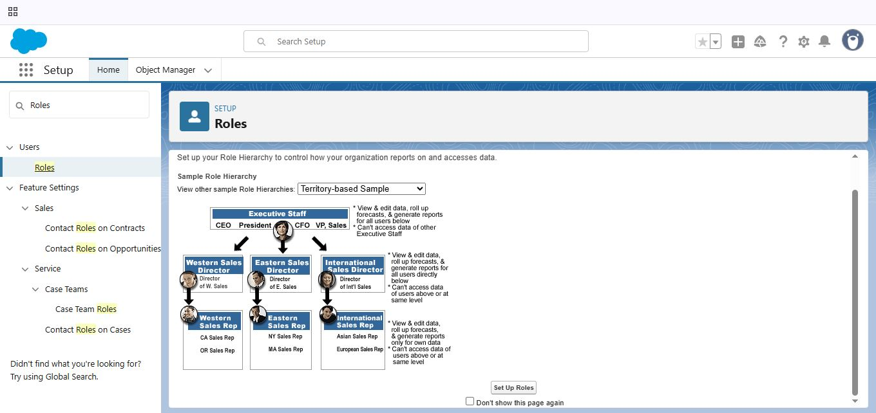

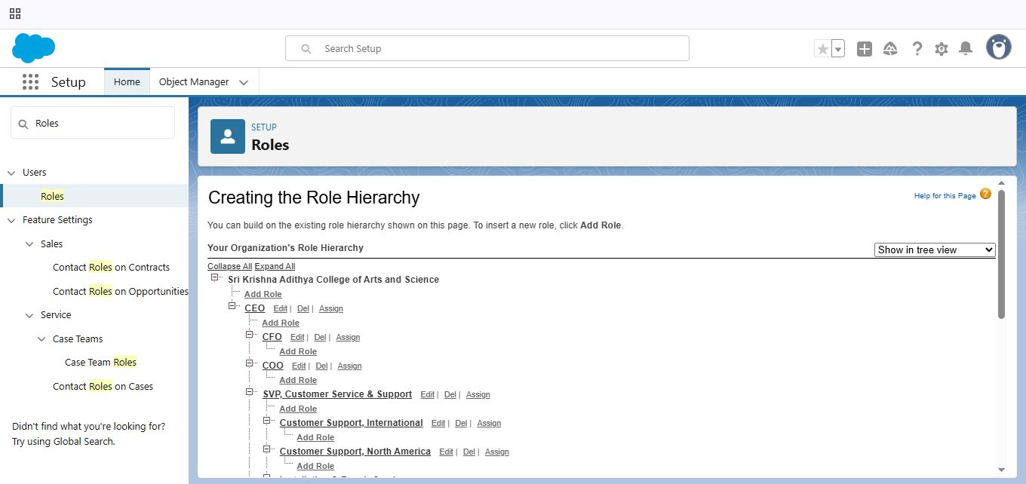

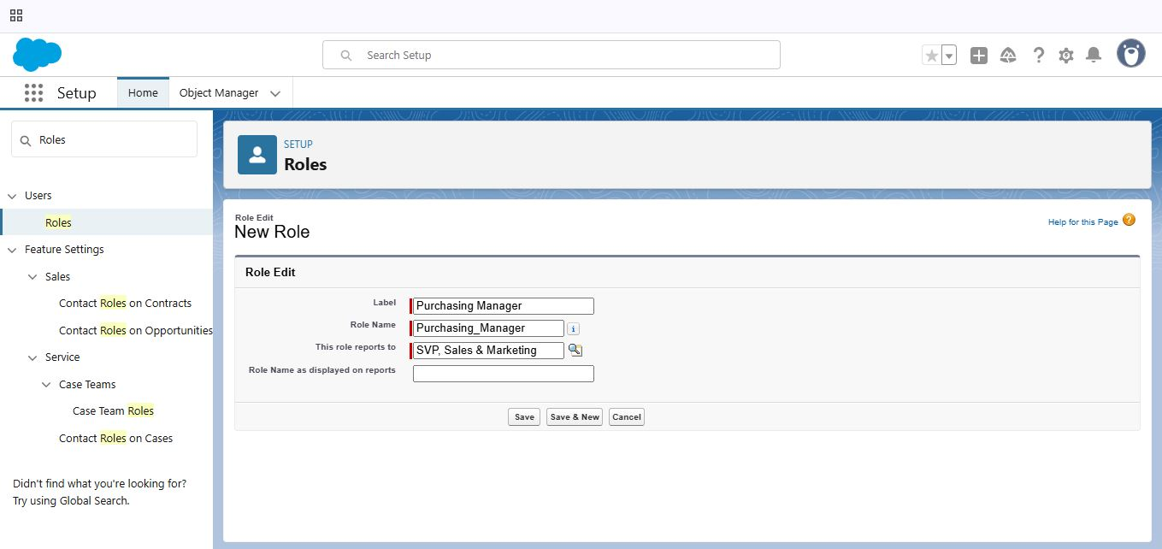

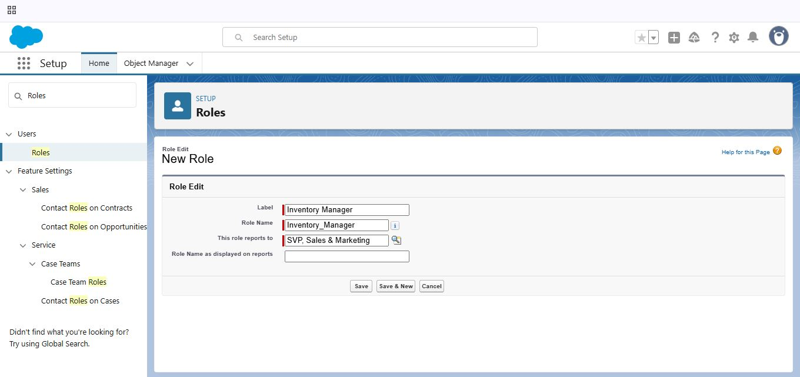

### 2.10 Permission Sets:

* Create a Permission Set:

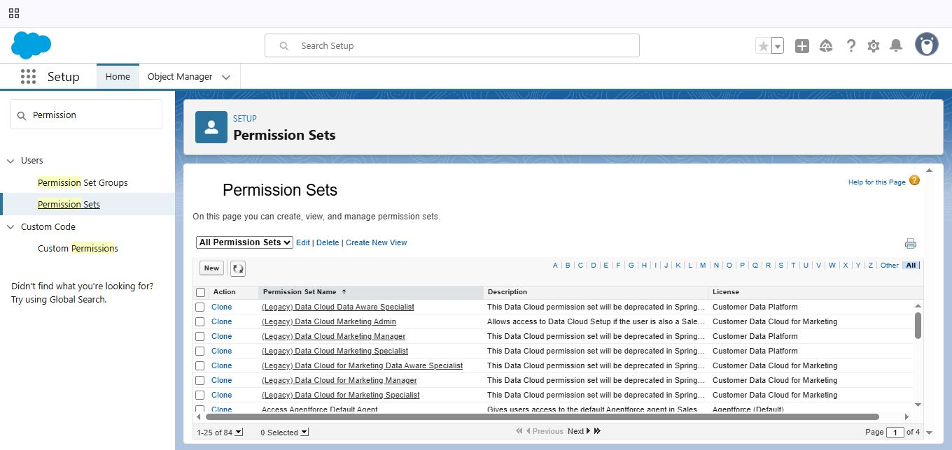

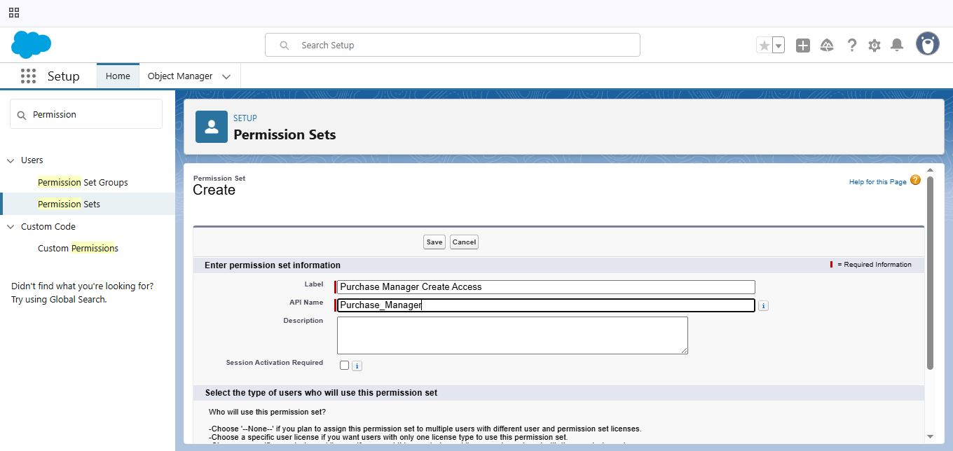

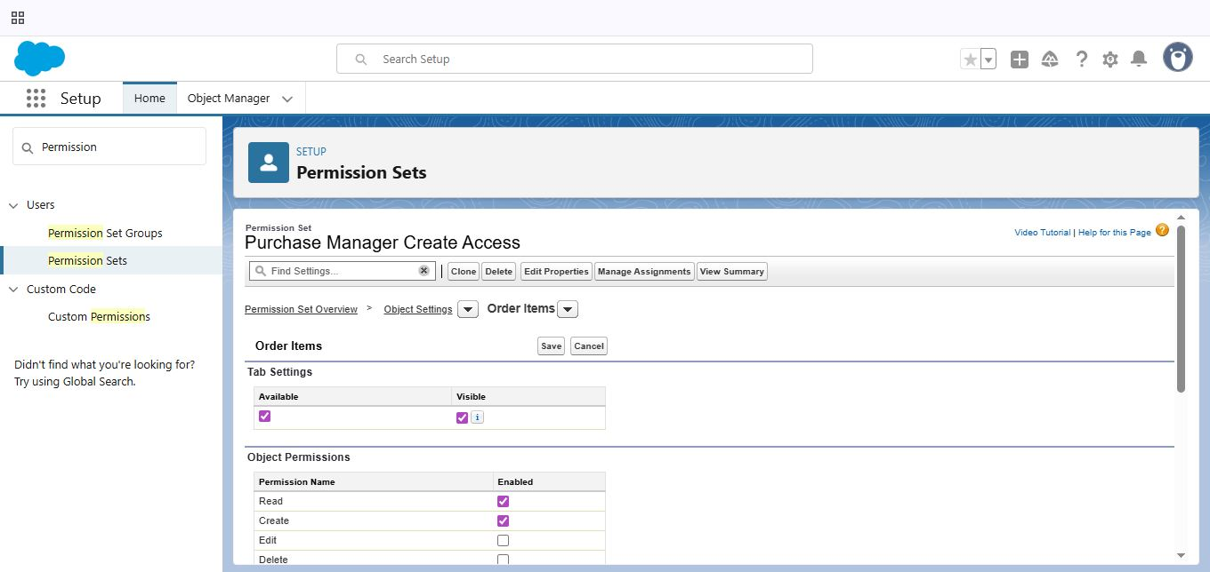

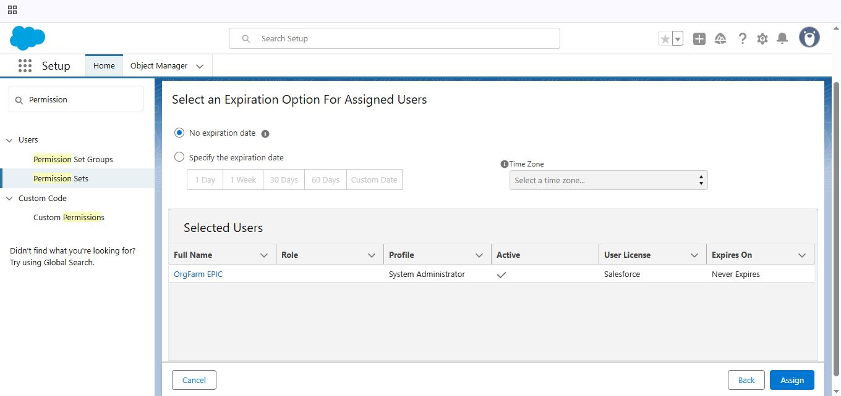

### 2.11 Flows:

* Create Flow to Update the Actual Delivery Date:

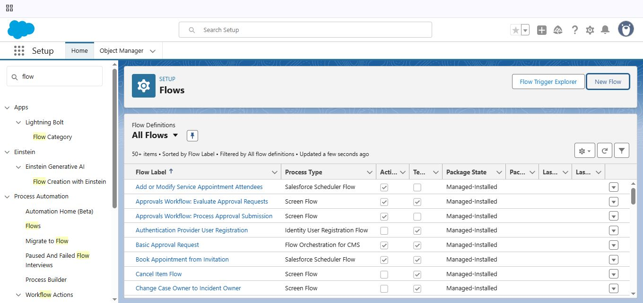

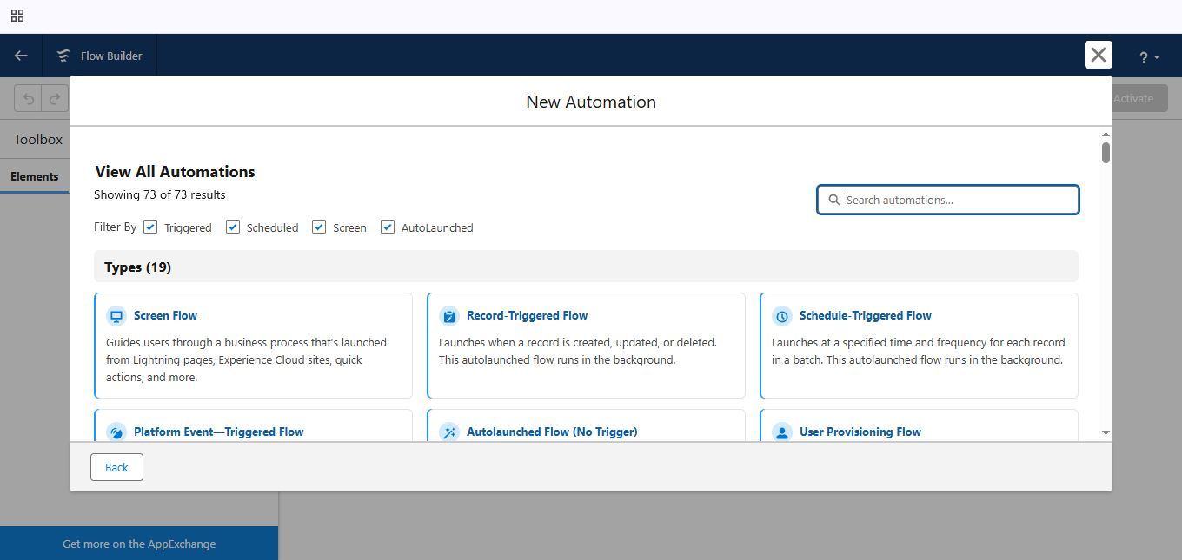

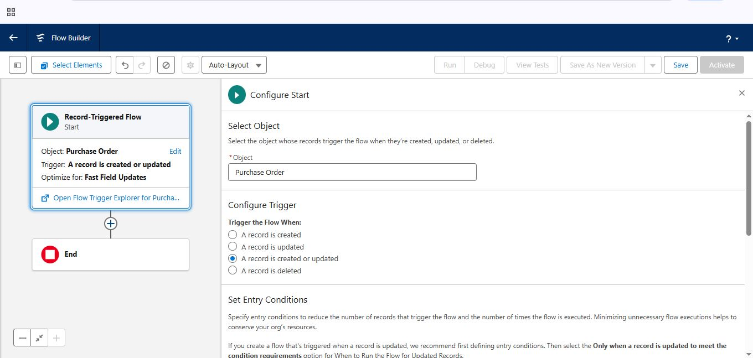

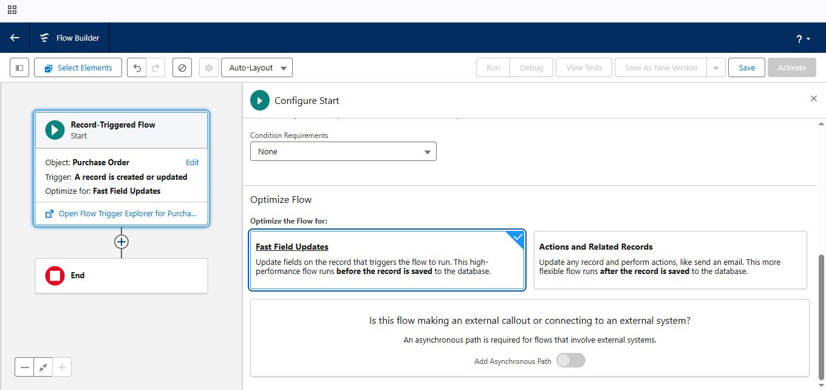

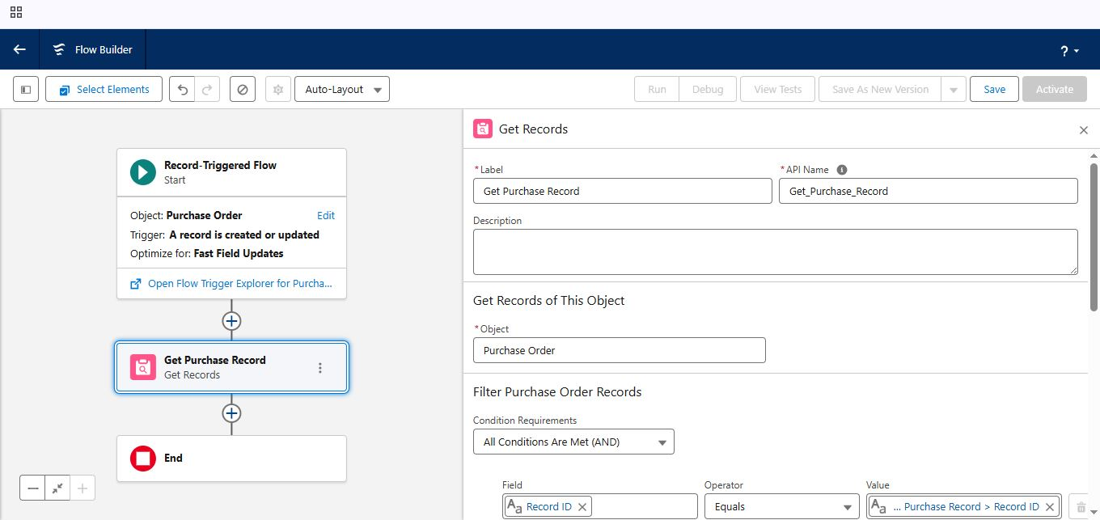

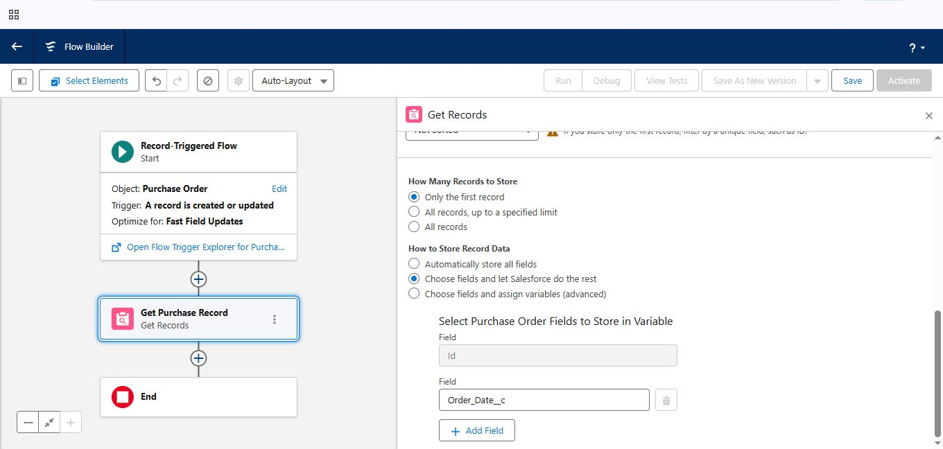

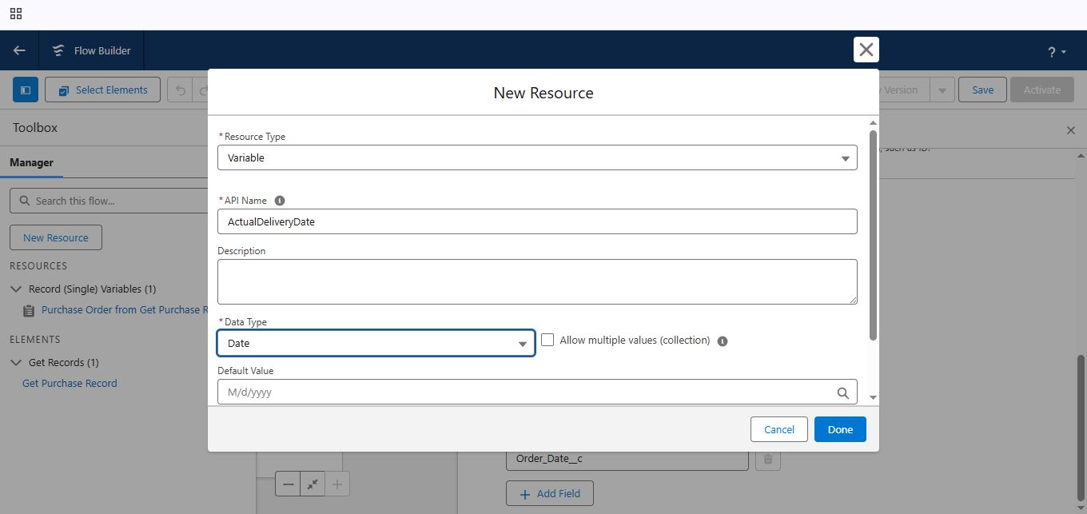

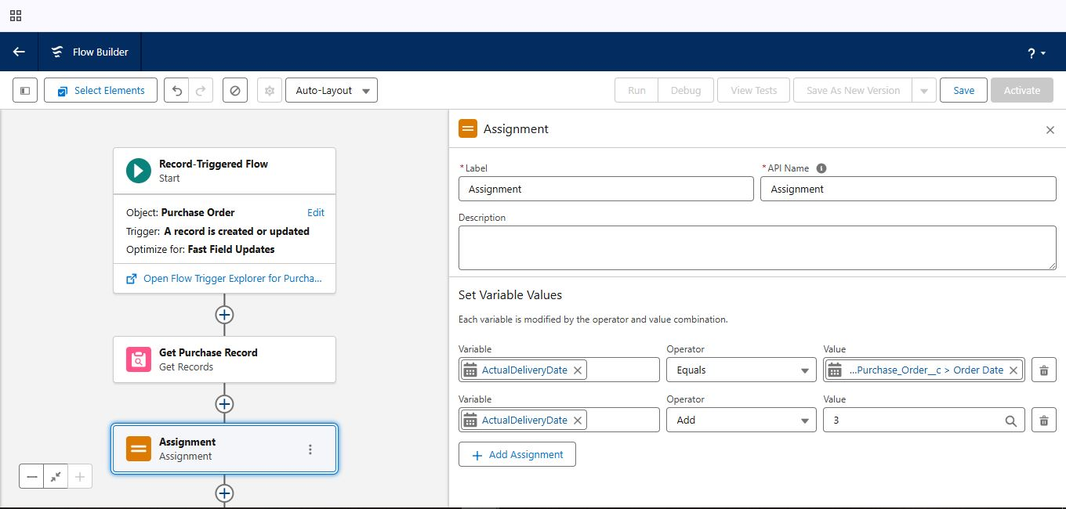

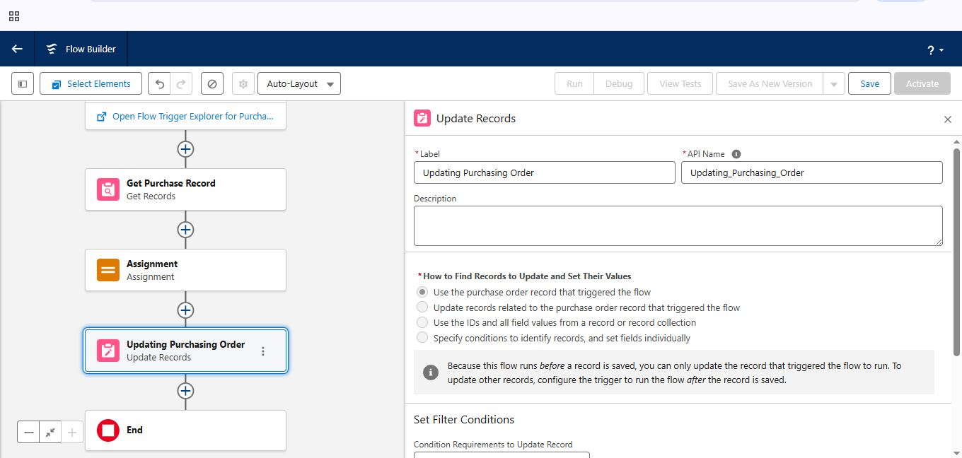

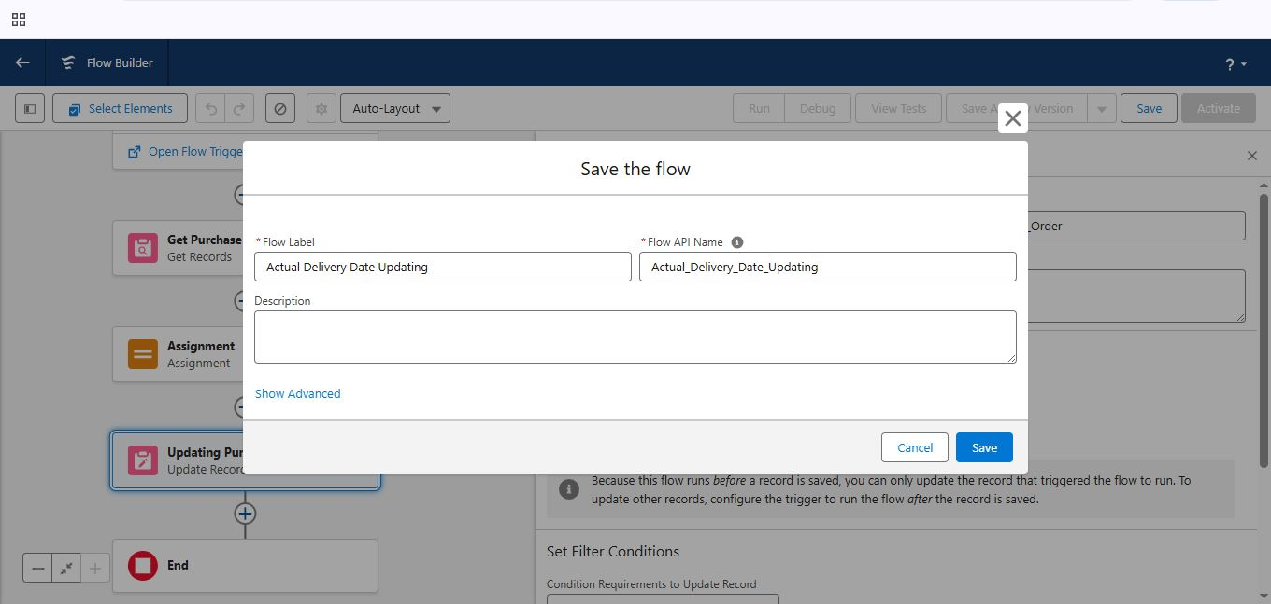

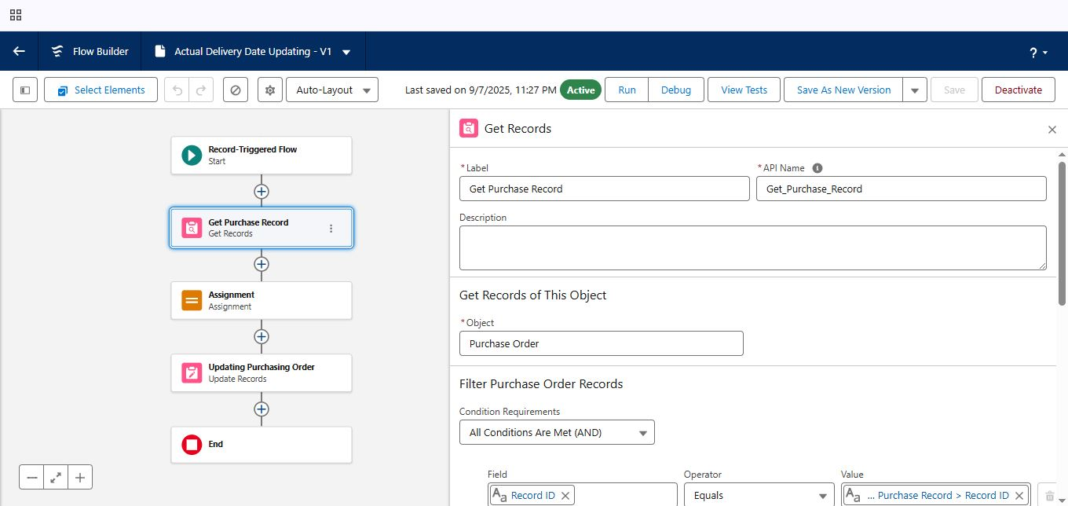

### 2.12 Triggers:

* Create a Trigger to calculate Total Amount on Order Item :

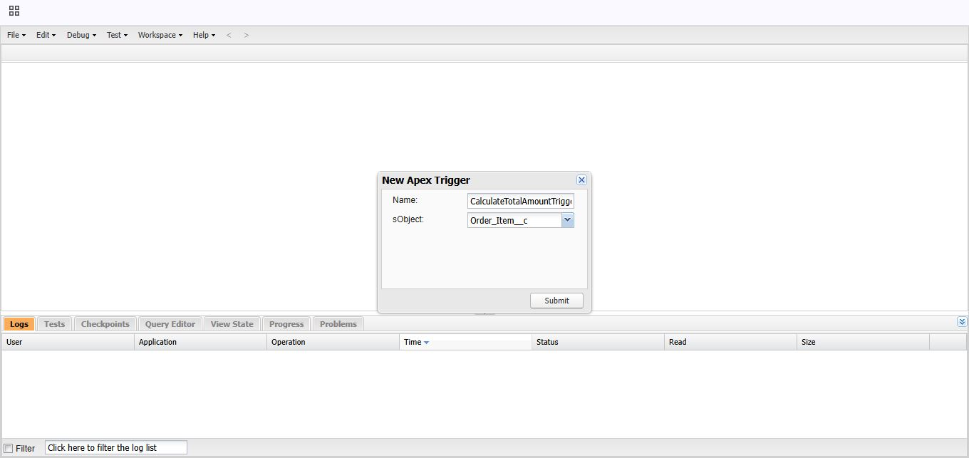

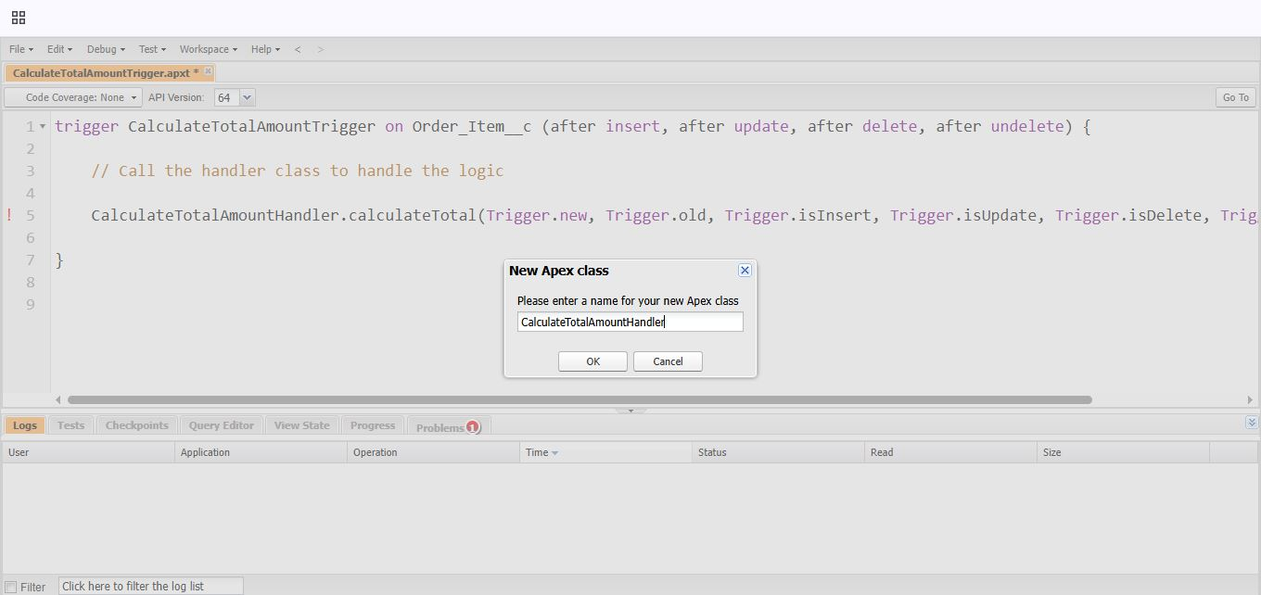

### 2.13 Reports:

* Create a Purchase Orders based in Suppliers(Summary) Report:

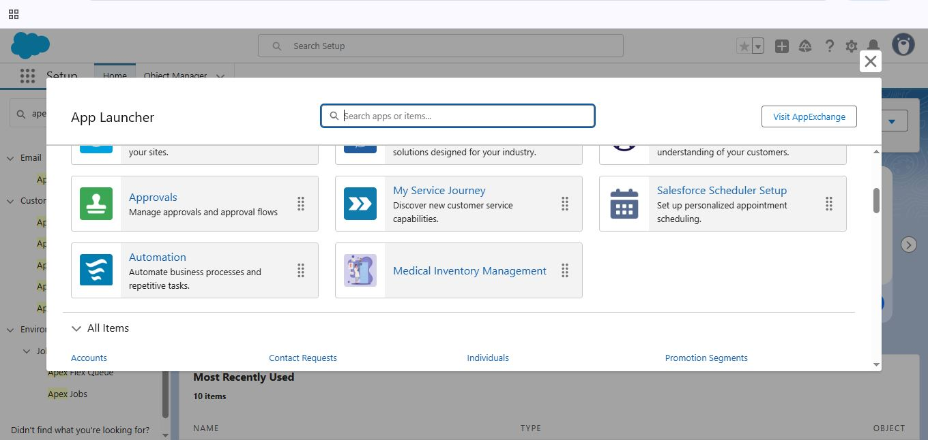

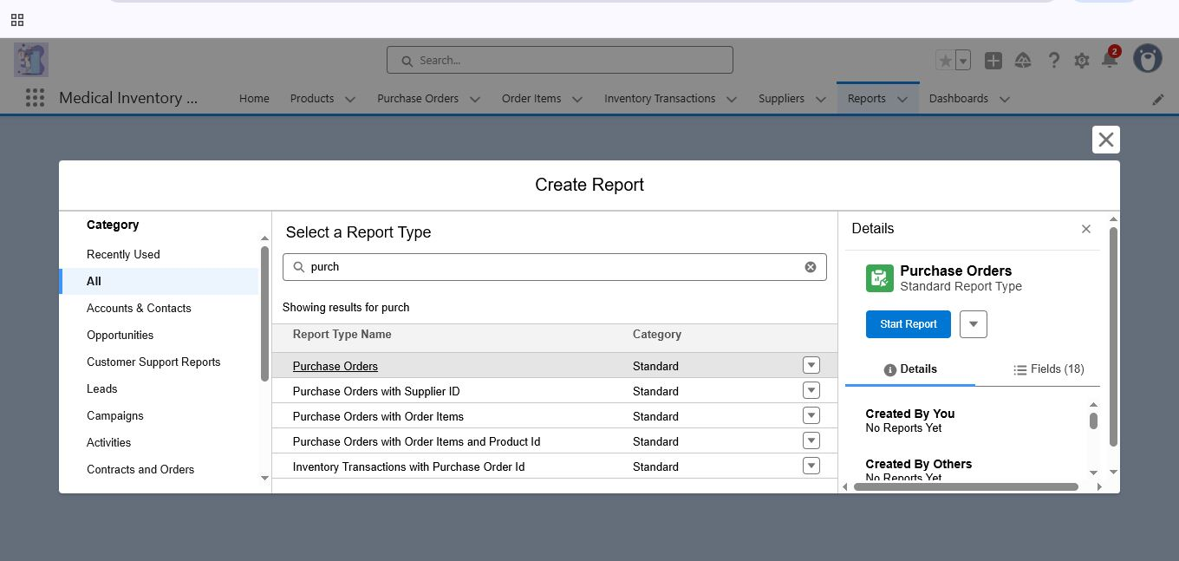

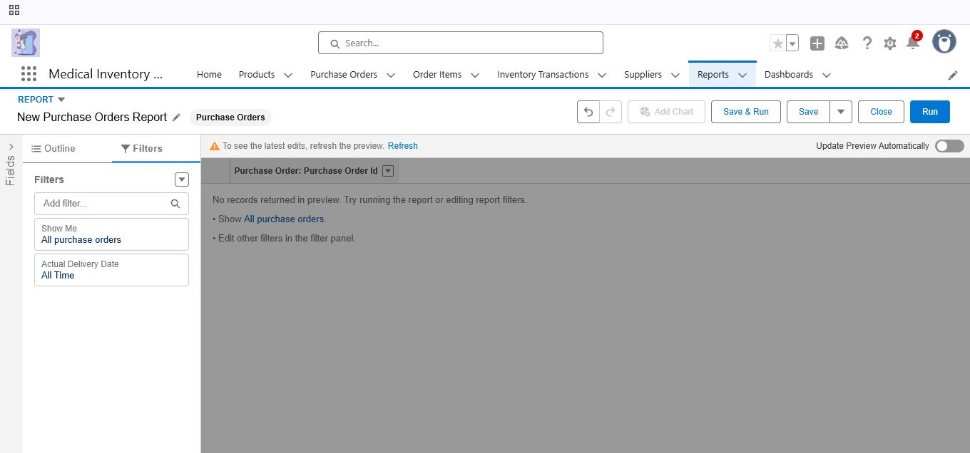

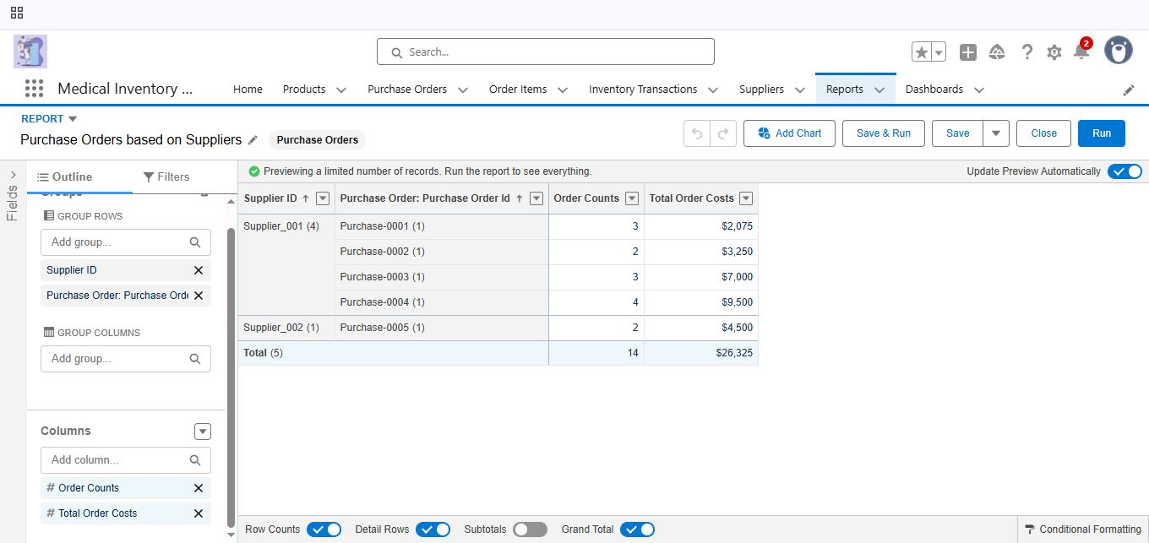

* Create a Complete Purchase Details Report:

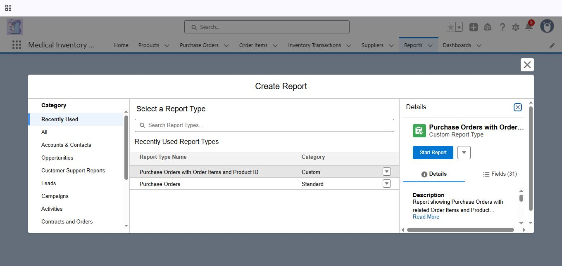

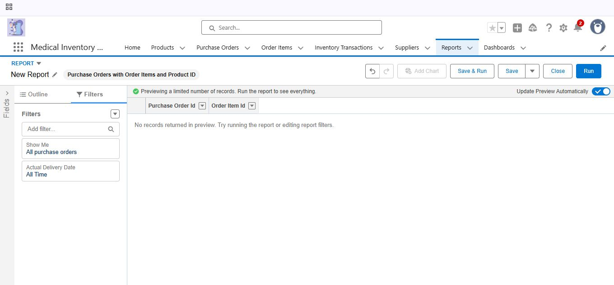

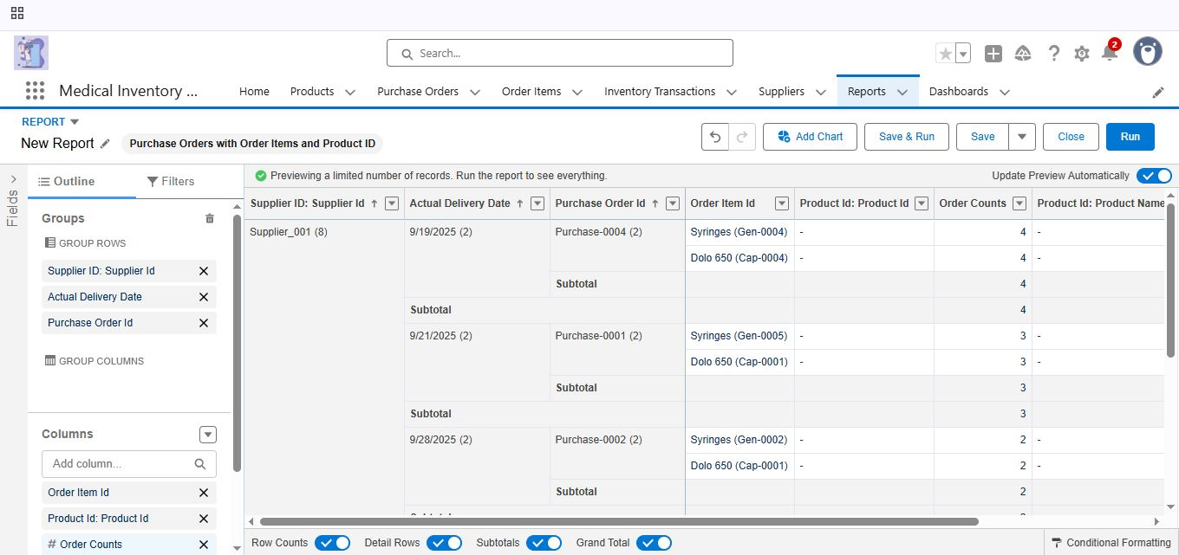

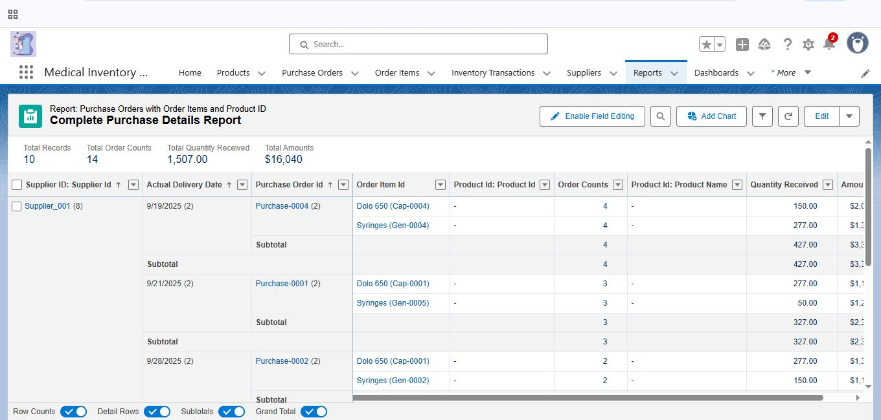

### 2.14 Dashboards:

* Create Dashboards:

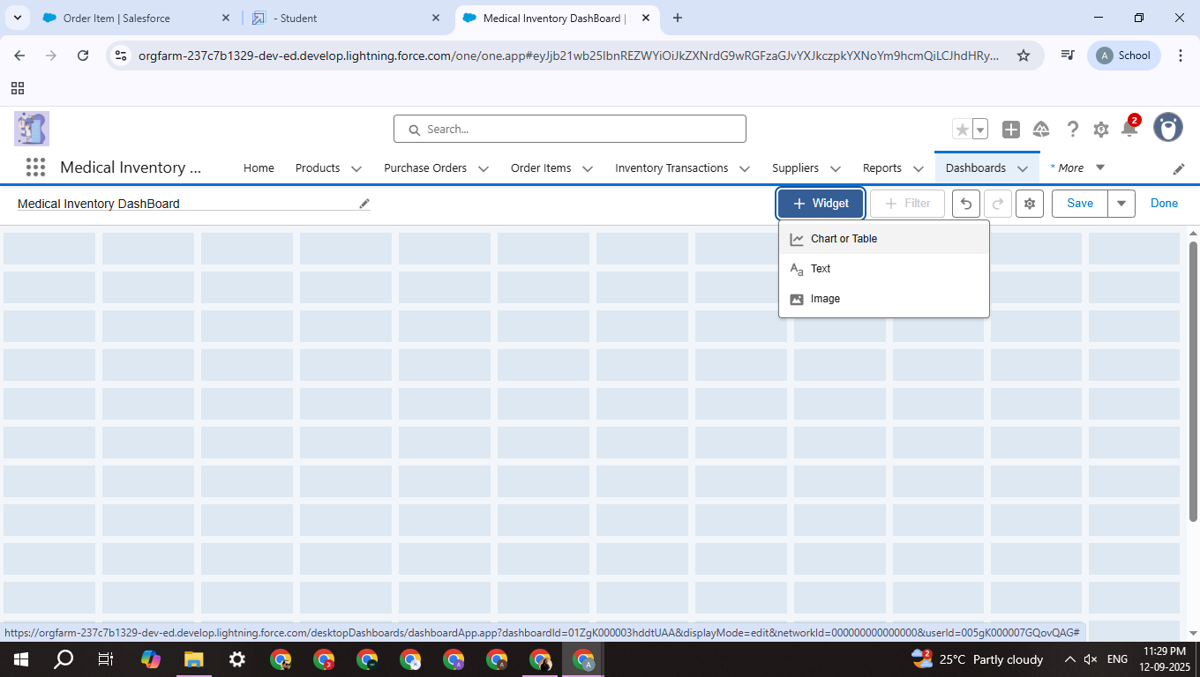

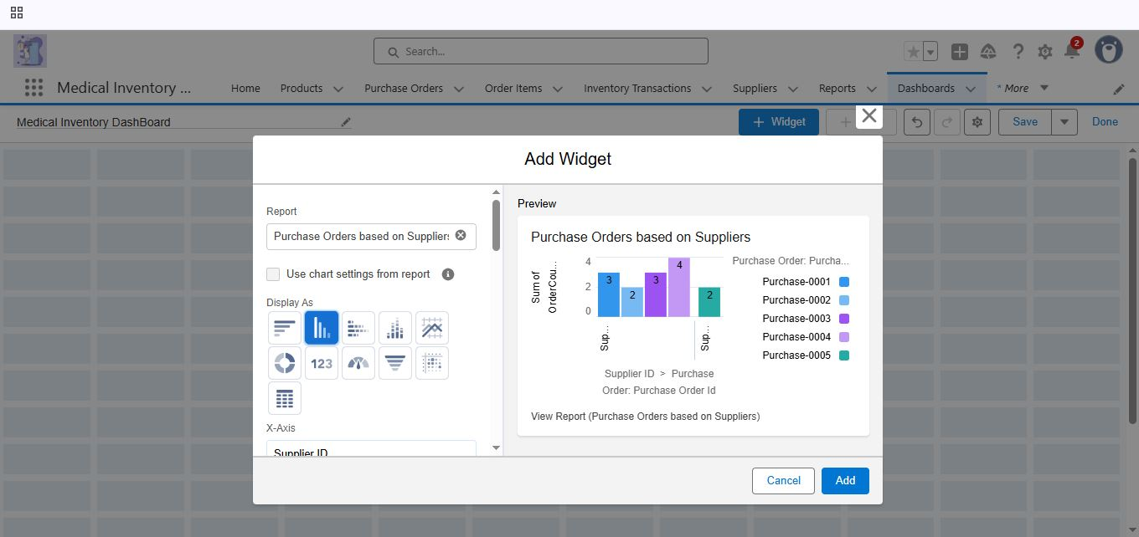

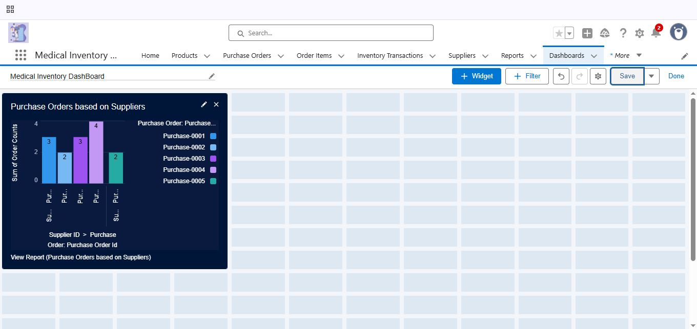

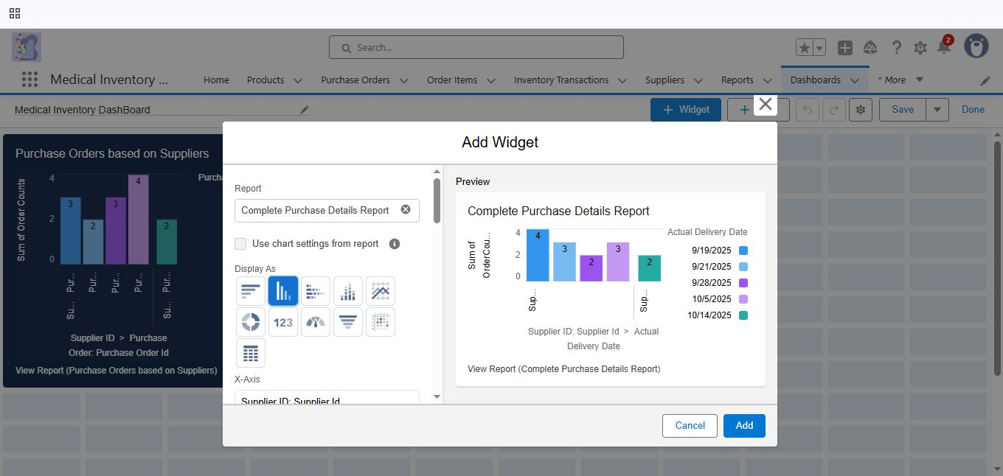

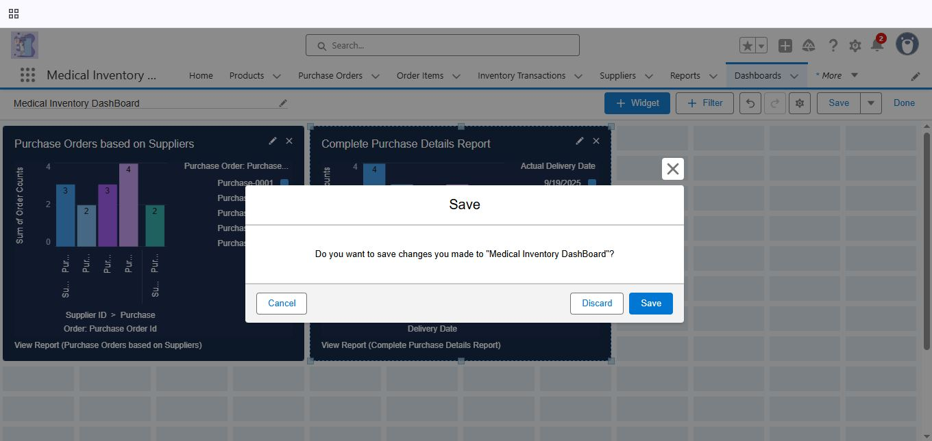

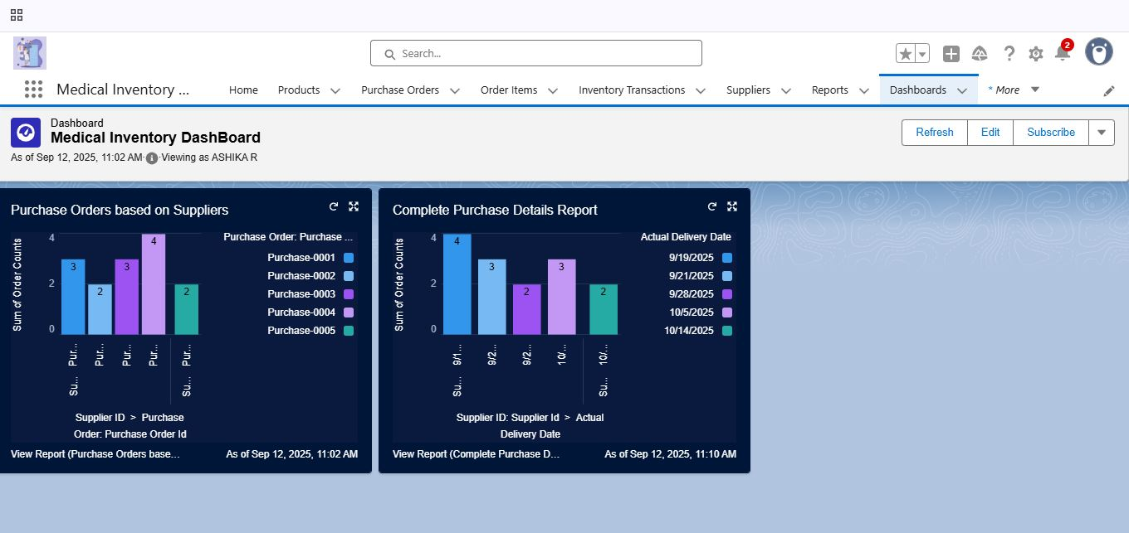

# 3. CONCLUSION

# The Medical Inventory Management System successfully streamlines the operations of medical inventory through a structured, automated Salesforce application. It improves efficiency, accuracy, and transparency in managing suppliers, purchase orders, product inventory, and expiry monitoring, helping medical organizations focus on delivering better healthcare services.

## APPENDIX:

* + **Source Code:** Provided in Apex Classes and Triggers

### CalculateTotalAmountTrigger.apxt:

## trigger CalculateTotalAmountTrigger on Order_Item__c (after insert, after update, after delete, after undelete) {

## // Call the handler class to handle the logic

## CalculateTotalAmountHandler.calculateTotal(Trigger.new, Trigger.old, Trigger.isInsert, Trigger.isUpdate, Trigger.isDelete, Trigger.isUndelete);}

### CalculateTotalAmountHandler.apxc:

public class CalculateTotalAmountHandler {

// Method to calculate the total amount for Purchase Orders based on related Order Items

public static void calculateTotal(List<Order_Item__c> newItems, List<Order_Item__c> oldItems, Boolean isInsert, Boolean isUpdate, Boolean isDelete, Boolean isUndelete) {

// Collect Purchase Order IDs affected by changes in Order_Item__c records

Set<Id> parentIds = new Set<Id>();

// For insert, update, and undelete scenarios

if (isInsert || isUpdate || isUndelete) {

for (Order_Item__c ordItem : newItems) {

parentIds.add(ordItem.Purchase_Order_Id__c);

}

}

// For update and delete scenarios

if (isUpdate || isDelete) {

for (Order_Item__c ordItem : oldItems) {

parentIds.add(ordItem.Purchase_Order_Id__c);

}

}

// Calculate the total amounts for affected Purchase Orders

Map<Id, Decimal> purchaseToUpdateMap = new Map<Id, Decimal>();

if (!parentIds.isEmpty()) {

// Perform an aggregate query to sum the Amount__c for each Purchase Order

List<AggregateResult> aggrList = [

SELECT Purchase_Order_Id__c, SUM(Amount__c) totalAmount

FROM Order_Item__c

WHERE Purchase_Order_Id__c IN :parentIds

GROUP BY Purchase_Order_Id__c

];

// Map the result to Purchase Order IDs

for (AggregateResult aggr : aggrList) {

Id purchaseOrderId = (Id)aggr.get('Purchase_Order_Id__c');

Decimal totalAmount = (Decimal)aggr.get('totalAmount');

purchaseToUpdateMap.put(purchaseOrderId, totalAmount);

}

// Prepare Purchase Order records for update

List<Purchase_Order__c> purchaseToUpdate = new List<Purchase_Order__c>();

for (Id purchaseOrderId : purchaseToUpdateMap.keySet()) {

Purchase_Order__c purchaseOrder = new Purchase_Order__c(Id = purchaseOrderId, Total_Order_costs__c = purchaseToUpdateMap.get(purchaseOrderId));

purchaseToUpdate.add(purchaseOrder);

}

// Update Purchase Orders if there are any changes

if (!purchaseToUpdate.isEmpty()) {

update purchaseToUpdate;}

}

}

}